

Module Title : Designing and Developing Object-Oriented Computer Programs

Assignment Title : MEDIA LIBRARY

Examination Cycle : MARCH 2018

Candidate Name : PYAE THUTA

Candidate No : 00179491

Centre Name : KMD COMPUTER CENTRE (YANGON)

Submission Date : January 2018

Important Notes :

* Please refer to the Assignment Presentation Requirements for advice on how to set out your assignment. These can be found on the NCC Education *Campus*. Scroll down the left hand side of the screen until you reach Personal Support. Click on this, and then on Policies and Advice. You will find the Assignment Presentation Requirements under the Advice section.
* You must familiarise yourself with the NCC Education Academic Dishonesty and Plagiarism Policy and ensure that you acknowledge all the sources which you use in your work. The policy is available on Campus. Follow the instructions above, but click on Policies rather than Advice.
* You must complete the ‘Statement and Confirmation of Own Work’. The form is available on the Policies section of *Campus*. Scroll down the left hand side until you reach Personal Support. Click on this and then click on Policies and Advice.
* Please make a note of the recommended word count. You could lose marks if you write 10%more or less than this.
* You must submit a paper copy and digital copy (on disk or similarly acceptable medium).Media containing viruses, or media which cannot be run directly, will result in a fail grade being awarded for this module.
* All electronic media will be checked for plagiarism.

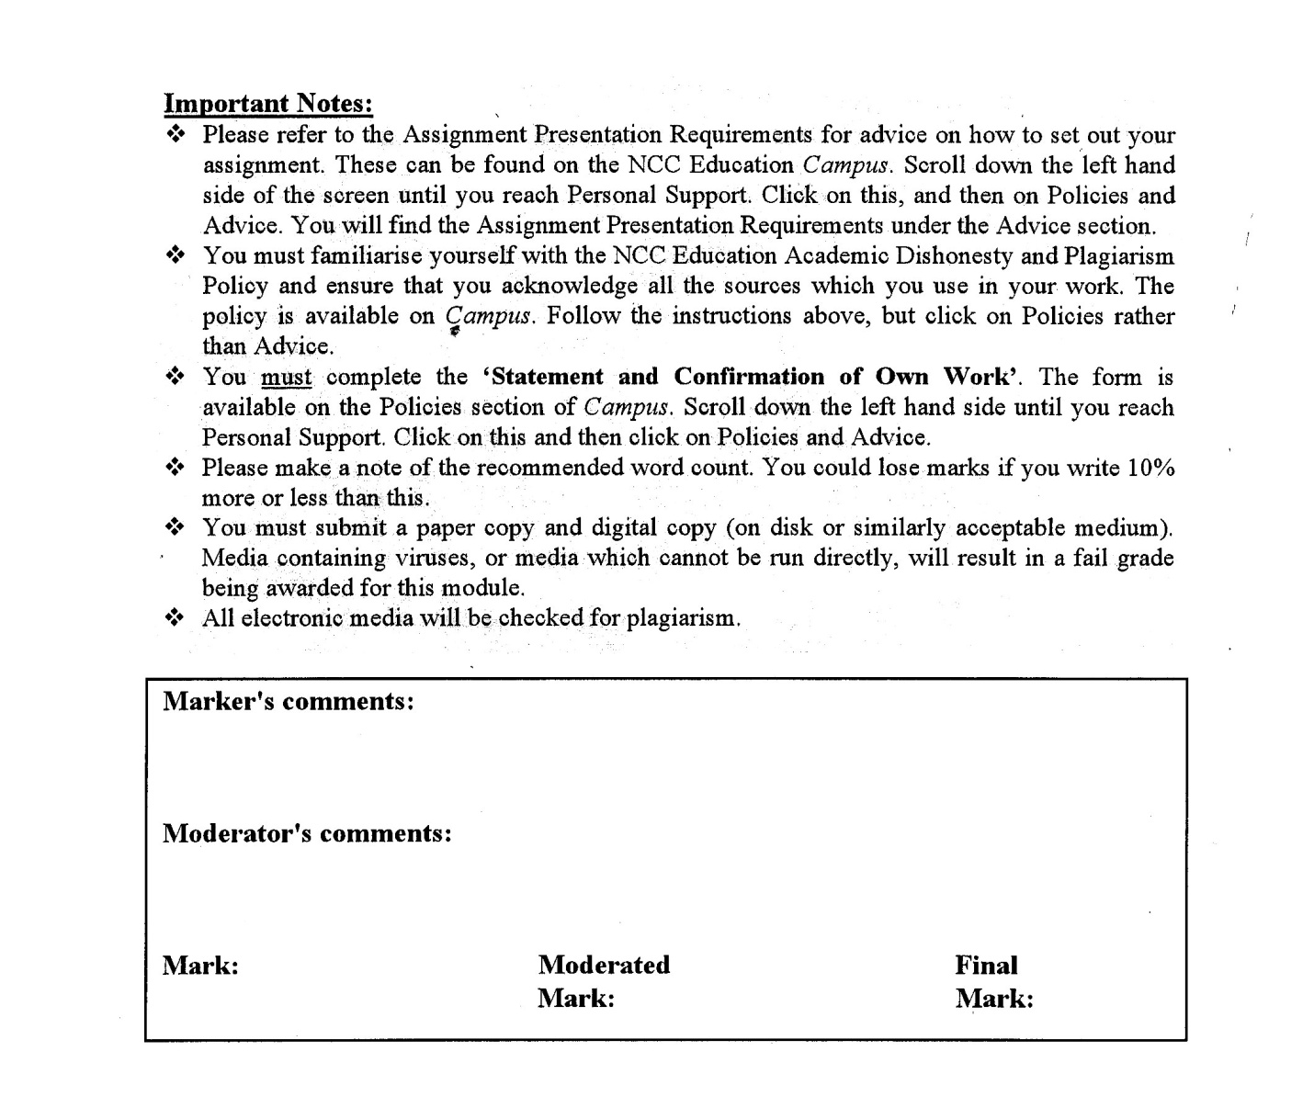



Statement and Confirmation of Own Work

Programme/Qualification name: L4DC

*All NCC Education assessed assignments submitted by students must have this statement as the cover page or it will not be accepted for marking. Please ensure that this statement is either firmly attached to the cover of the assignment or electronically inserted into the front of the assignment.*

Student declaration

I have read and understood NCC Education’s Policy on Academic Dishonesty and Plagiarism.

I can confirm the following details.

Student ID/Registration number : 00179491

Name : PYAE THUTA

Centre Name : KMD COMPUTER CENTRE (YANGON)

Module Name : Designing and Developing Object-Oriented Computer

Programs

Module Leader :

I confirm that this is my own work and that I have not plagiarised any part of it. I have also noted the assessment criteria and pass mark for assignments.

Due Date : 26 Septmeber 2018

Student Signature : thuta

Submission Date : 23 January 2019

# Introduction

The software should contain a proper storing system. It should be able to find various files which a user wants. The user should be asked for the directories. Add the files to an internal storage. The application will scan the directories and add them to the storage at the beginning. Record the data as the indicated file types.

It should be able to support extensions of any number of characters and record the information. Various users can be used. Should contain the system of creating accounts and logging in. Allow users to view the media library of others. Also allow adding, removed and edit their files. Rating the files must be available.

Users should be able to track according to the data, type and rating. The main interface shows a series of button to show a sorted list of all files. Should be able to sort any piece of data stored.

Task 1

# Analysis

Storing media files can be a lot of track. The software should have the permissions to find all the various media files which a user wants. The software should ask the user for a set of directories. All the files added will be saved between the invocation and application. When the user starts the application, it will scan the subdirectories of the files. Then add that files to the storage. The software will identify the files according to the extensions. This will be done by checking the exact file names and analyzing the string characters after the dot. (e.g. .txt, .doc, .pdf, etc.).

The software should support extensions of any numbers of characters. When the software encounters a file, it should also record the information such as Filename, Location on drive, Type, Size, Date modified. The software should be able to use by various users. A user can create an account or log in into an existing account. The users can stored the data only in the local system on which the software is working. The software will allow the users to view the media libraries of other users. The directories of the users may be different. So, the software will store the directories the users track.

The software should have the systems for adding, removing and editing the files they have added. If a file is removed, the user will not be able to find the data. The users can rate the file from one to ten. The users need to update data themselves. Users can be able to search the files according to the date, type and the rating of the files. The users can also search files based on the text containing the notes. The main interface of the application should contain a series of buttons to click and find all the files stored in the system. The users should be able to sort on any piece of data about any files.

# Assumption

The software should let users to save the media files and play them. GUI is very Important for a media software so that users would be confident to use the software. I choose red and white color for the software. That colors are light and fancy. So, I think users will enjoy the color. I search for some images for background images. The design of the software should not be very complex so that the users can understand the purpose of the software easily.

Every user will need an account to use the software because the software will record the user names when they save a file. I will create a form that lets users to register new accounts and a form that let users to log into their accounts. When users register a new account, the software will record the user’s information. The users will get an ID number whenever they register a new account. There is only a user ID number for an account. To log into their account, the users will need to input correct email and correct password. The users will also be able to edit their information. The software will have a form that let users to view their personal information and to edit their information. According to the task, the software must let users to save the media files. So, the software will have a form that let users to search the files according to the filename and file type. The users will be able to save the media files with extensions according to the file types. Whenever the user saves the media files, the files will get a file number. There will be four file types (document files, movie files, image files and audio files) to save the files. The user can play the media file they chose.

Moreover, users must be able to search for the media files. There is a form for users to search the media according to the file type. The users will also be able to view the properties of the media files. The properties may contain user name, file name, file type, file size, file location and the date that the user created the file. The users can also be able to rate the media files from one to ten. Every user can view the media files of the others. A user can view the properties and rating of the media files of the others.

## System Codes

frmStart.cs

using System;

using System.Collections.Generic;

using System.ComponentModel;

using System.Data;

using System.Drawing;

using System.Linq;

using System.Text;

using System.Threading.Tasks;

using System.Windows.Forms;

namespace FirstAssignment

{

public partial class frmStart : Form

{

public frmStart()

{

InitializeComponent();

}

private void button1_Click(object sender, EventArgs e)

{

frmUserLogin fl = new frmUserLogin();

fl.Show();

this.Hide();

}

private void btnQuit_Click(object sender, EventArgs e)

{

MessageBox.Show(" Are you sure you want to exit", "Are You Sure", MessageBoxButtons.OKCancel, MessageBoxIcon.Question);

Close();

}

private void frmStart_Load(object sender, EventArgs e)

{

}

private void label2_Click(object sender, EventArgs e)

{

}

private void button2_Click(object sender, EventArgs e)

{

Form1 a = new Form1();

a.Show();

}

}

}

User_Registeration.cs

using System;

using System.Collections.Generic;

using System.ComponentModel;

using System.Data;

using System.Drawing;

using System.Linq;

using System.Text;

using System.Threading.Tasks;

using System.Windows.Forms;

namespace FirstAssignment

{

public partial class Form1 : Form

{

public static string user;

ds_UserRegisterTableAdapters.UsersTableAdapter urt = new ds_UserRegisterTableAdapters.UsersTableAdapter();

public Form1()

{

InitializeComponent();

}

private void Form1_Load(object sender, EventArgs e)

{

GetID();

}

private void GetID()

{

DataTable dtt = new DataTable();

dtt = urt.GetData();

if ( dtt.Rows.Count == 0)

{

txtID.Text = "ML.1";

}

else

{

int sizerow = dtt.Rows.Count - 1;

string oldid = dtt.Rows[sizerow][0].ToString();

int newid = Convert.ToInt32(oldid.Substring(3, 1));

if ( newid >= 1 && newid < 9)

{

txtID.Text = "ML." + (newid + 1);

}

else if ( newid >= 9 && newid < 99)

{

txtID.Text = "ML." + (newid + 1);

}

else if ( newid >=99 && newid <999)

{

txtID.Text = "ML." + (newid+1);

}

}

}

public void Clear()

{

txtName.Clear();

txtAge.Clear();

txtEmail.Clear();

txtPassword.Clear();

txtComfirm.Clear();

}

public string GenderCheck()

{

if ( rdoMale.Checked == true)

{

return " Male ";

}

else if ( rdoFemale.Checked == true)

{

return " Female ";

}

else

{

return "";

}

}

public Boolean DataChecking ()

{

if ( txtName.Text == "")

{

MessageBox.Show(" Please enter User Name ", " NUll Data ", MessageBoxButtons.OK, MessageBoxIcon.Error);

txtName.Focus();

return false;

}

else if ( txtAge.Text == "")

{

MessageBox.Show(" Please enter your age", " NUll Data ", MessageBoxButtons.OK, MessageBoxIcon.Error);

txtAge.Focus();

return false;

}

else if ( txtEmail.Text == "")

{

MessageBox.Show(" Please enter Email", " NUll Data ", MessageBoxButtons.OK, MessageBoxIcon.Error);

txtEmail.Focus();

return false;

}

else if ( txtPassword.Text == "")

{

MessageBox.Show(" Please enter Password", " NUll Data ", MessageBoxButtons.OK, MessageBoxIcon.Error);

txtPassword.Focus();

return false;

}

else if ( txtComfirm.Text == "")

{

MessageBox.Show(" Please Comfirm the email", " NUll Data ", MessageBoxButtons.OK, MessageBoxIcon.Error);

txtComfirm.Focus();

return false;

}

else if ( txtComfirm.Text != txtPassword.Text )

{

MessageBox.Show(" The Psswords are not march", "Not march", MessageBoxButtons.OK, MessageBoxIcon.Error);

txtPassword.Focus();

return false;

}

else

{

return true;

}

}

private void btnSave_Click(object sender, EventArgs e)

{

if (DataChecking() == true )

{

urt.Insert(txtID.Text, txtName.Text, GenderCheck(), txtAge.Text, txtEmail.Text, txtPassword.Text, txtComfirm.Text);

MessageBox.Show("Welcome " + " ' " + txtName.Text + " ' " + ". Your account is created.", " Account Created");

user = txtName.Text;

Clear();

Close();

}

}

private void textBox2_TextChanged(object sender, EventArgs e)

{

}

private void rdoFemale_CheckedChanged(object sender, EventArgs e)

{

}

private void btnExit_Click(object sender, EventArgs e)

{

Close();

}

private void btnClear_Click(object sender, EventArgs e)

{

}

private void picSee_Click(object sender, EventArgs e)

{

txtPassword.PasswordChar = char.MinValue;

picSee.SendToBack();

}

private void picUnsee_Click(object sender, EventArgs e)

{

txtPassword.PasswordChar = Convert.ToChar("*");

picUnsee.SendToBack();

}

private void pictureBox1_Click(object sender, EventArgs e)

{

txtComfirm.PasswordChar = char.MinValue;

pictureBox1.SendToBack();

}

private void pictureBox2_Click(object sender, EventArgs e)

{

txtComfirm.PasswordChar = Convert.ToChar("*");

pictureBox2.SendToBack();

}

}

}

frmUserLogin.cs

using System;

using System.Collections.Generic;

using System.ComponentModel;

using System.Data;

using System.Drawing;

using System.Linq;

using System.Text;

using System.Threading.Tasks;

using System.Windows.Forms;

namespace FirstAssignment

{

public partial class frmUserLogin : Form

{

public static string email, password;

ds_UserRegisterTableAdapters.UsersTableAdapter uta = new ds_UserRegisterTableAdapters.UsersTableAdapter();

public frmUserLogin()

{

InitializeComponent();

}

private void button3_Click(object sender, EventArgs e)

{

frmStart fs = new frmStart();

fs.Show();

}

private void button2_Click(object sender, EventArgs e)

{

if (txtEmail.Text == "" )

{

MessageBox.Show("Please enter Email", "Null Data", MessageBoxButtons.OK, MessageBoxIcon.Error);

txtEmail.Focus();

}

else if ( txtPassword.Text == "")

{

MessageBox.Show("Please enter Password", "Null Data", MessageBoxButtons.OK, MessageBoxIcon.Error);

txtPassword.Focus();

}

else

{

DataTable dt = new DataTable();

dt = uta.UserLogin(txtEmail.Text, txtPassword.Text);

if ( dt.Rows.Count > 0 )

{

MessageBox.Show("Successfully Log In ", "Welcome");

email = txtEmail.Text;

password = txtPassword.Text;

this.Hide();

frmMain fm = new frmMain();

fm.Show();

}

else

{

MessageBox.Show("The Email or Password is wrong. Please try again ! ", "Wrong Input", MessageBoxButtons.OK, MessageBoxIcon.Error);

txtEmail.Clear();

txtPassword.Clear();

txtEmail.Focus();

}

}

}

private void frmUserLogin_Load(object sender, EventArgs e)

{

}

private void linkLabel1_LinkClicked(object sender, LinkLabelLinkClickedEventArgs e)

{

Form1 f = new Form1();

f.Show();

}

private void pictureBox1_Click(object sender, EventArgs e)

{

txtPassword.PasswordChar = Convert.ToChar("*");

picUnHide.SendToBack();

}

private void picHide_Click(object sender, EventArgs e)

{

txtPassword.PasswordChar = char.MinValue;

picHide.SendToBack();

}

private void txtEmail_TextChanged(object sender, EventArgs e)

{

}

private void txtPassword_TextChanged(object sender, EventArgs e)

{

}

private void txtPassword_TextChanged_1(object sender, EventArgs e)

{

}

}

}

frmMain.cs

using System;

using System.Collections.Generic;

using System.ComponentModel;

using System.Data;

using System.Drawing;

using System.Linq;

using System.Text;

using System.Threading.Tasks;

using System.Windows.Forms;

namespace FirstAssignment

{

public partial class frmMain : Form

{

public frmMain()

{

InitializeComponent();

}

private void frmMain_Load(object sender, EventArgs e)

{

}

private void profileToolStripMenuItem_Click(object sender, EventArgs e)

{

frmProfileEdit fp = new frmProfileEdit();

fp.Show();

}

private void label1_Click(object sender, EventArgs e)

{

}

private void mnuCreat_Click(object sender, EventArgs e)

{

frmCreating fc = new frmCreating();

fc.Show();

}

}

}

frmProfileEdit.cs

using System;

using System.Collections.Generic;

using System.ComponentModel;

using System.Data;

using System.Drawing;

using System.Linq;

using System.Text;

using System.Threading.Tasks;

using System.Windows.Forms;

namespace FirstAssignment

{

public partial class frmProfileEdit : Form

{

ds_UserRegisterTableAdapters.UsersTableAdapter utd = new ds_UserRegisterTableAdapters.UsersTableAdapter();

public frmProfileEdit()

{

InitializeComponent();

}

private void frmProfileEdit_Load(object sender, EventArgs e)

{

txtEmail.Text = frmUserLogin.email;

txtPassword.Text = frmUserLogin.password;

DataTable dtt = new DataTable();

dtt = utd.UserLogin(txtEmail.Text, txtPassword.Text);

txtID.Text = dtt.Rows[0][0].ToString();

txtName.Text = dtt.Rows[0][1].ToString();

txtAge.Text = dtt.Rows[0][3].ToString();

}

private Boolean check()

{

if ( txtName.Text == "")

{

MessageBox.Show(" Please enter User Name ", " NUll Data ", MessageBoxButtons.OK, MessageBoxIcon.Error);

txtName.Focus();

return false;

}

else if ( txtAge.Text == "")

{

MessageBox.Show(" Please enter your age", " NUll Data ", MessageBoxButtons.OK, MessageBoxIcon.Error);

txtAge.Focus();

return false;

}

else if (txtPassword.Text == "")

{

MessageBox.Show(" Please enter Password", " NUll Data ", MessageBoxButtons.OK, MessageBoxIcon.Error);

txtPassword.Focus();

return false;

}

else

{

return true;

}

}

private void label9_Click(object sender, EventArgs e)

{

}

private void label8_Click(object sender, EventArgs e)

{

}

private void textBox1_TextChanged(object sender, EventArgs e)

{

}

private void txtID_TextChanged(object sender, EventArgs e)

{

}

private void btnSave_Click(object sender, EventArgs e)

{

if ( check ()== true)

{

utd.UpdateData(txtName.Text, txtAge.Text, txtPassword.Text, txtID.Text);

MessageBox.Show("Updated Succesfully", " Updated");

}

}

private void txtEmail_TextChanged(object sender, EventArgs e)

{

}

private void button1_Click(object sender, EventArgs e)

{

utd.DeleteData(txtID.Text);

MessageBox.Show("Data Deleted Successfully", "Deleted",MessageBoxButtons.OK, MessageBoxIcon.Information );

this.Hide();

frmUserLogin fm = new frmUserLogin();

fm.Show();

frmMain m = new frmMain();

m.Hide();

}

private void picUnseen_Click(object sender, EventArgs e)

{

txtPassword.PasswordChar = Convert.ToChar("*");

picUnseen.SendToBack();

}

private void picSeen_Click(object sender, EventArgs e)

{

txtPassword.PasswordChar = char.MinValue;

picSeen.SendToBack();

}

}

}

frmCreating.cs

using System;

using System.Collections.Generic;

using System.ComponentModel;

using System.Data;

using System.Drawing;

using System.Linq;

using System.Text;

using System.Threading.Tasks;

using System.Windows.Forms;

using System.IO;

namespace FirstAssignment

{

public partial class frmCreating : Form

{

ds_UserRegisterTableAdapters.UsersTableAdapter urta = new ds_UserRegisterTableAdapters.UsersTableAdapter();

ds_UserRegisterTableAdapters.PathFileMLTableAdapter f = new ds_UserRegisterTableAdapters.PathFileMLTableAdapter();

ds_UserRegisterTableAdapters.DetailFilesTableAdapter fd = new ds_UserRegisterTableAdapters.DetailFilesTableAdapter();

DataTable dt = new DataTable();

DataRow dr;

string userid;

public frmCreating()

{

InitializeComponent();

}

private void GetID()

{

DataTable dtt = new DataTable();

dtt = f.GetData();

if (dtt.Rows.Count == 0)

{

txtFileNo.Text = "ML_1";

}

else

{

int sizerow = dtt.Rows.Count - 1;

string oldid = dtt.Rows[sizerow][0].ToString();

int newid = Convert.ToInt32(oldid.Substring(3, 1));

if (newid >= 1 && newid < 9)

{

txtFileNo.Text = "ML_" + (newid + 1);

}

else if (newid >= 9 && newid < 99)

{

txtFileNo.Text = "ML_" + (newid + 1);

}

else if (newid >= 99 && newid < 999)

{

txtFileNo.Text = "ML_" + (newid + 1);

}

}

}

private void frmCreating_Load(object sender, EventArgs e)

{

DataTable dtt = new DataTable();

dtt = urta.UserLogin(frmUserLogin.email, frmUserLogin.password);

lblName.Text = dtt.Rows[0][1].ToString();

userid = dtt.Rows[0][0].ToString();

btnSave.Enabled = false;

GridShow();

btnUpdate.Enabled = false;

btnDelete.Enabled = false;

GetID();

btnPlay.Enabled = false;

}

public static string display;

private void GridShow()

{

dr = dt.NewRow();

dt.Columns.Add("File Name").ToString();

dt.Columns.Add("File Type").ToString();

dt.Columns.Add("File Size").ToString();

dt.Columns.Add("File Location").ToString();

dt.Columns.Add("Date").ToString();

dgvAdd.Refresh();

dgvAdd.DataSource = dt;

}

private void button3_Click(object sender, EventArgs e)

{

DataTable dts = new DataTable();

dts = f.GetData();

for (int p = 0; p < dts.Rows.Count; p++)

{

string fname = dts.Rows[p][0].ToString();

DataTable d = new DataTable();

d = f.getfilename(lblFilename.Text);

if (txtChoose.Text == "")

{

MessageBox.Show("Choose a file first", " Null Data", MessageBoxButtons.OK, MessageBoxIcon.Error);

}

else if (cboFiletype.Text == "")

{

MessageBox.Show("Choose File Type", " Null Data", MessageBoxButtons.OK, MessageBoxIcon.Error);

}

else if (d.Rows.Count > 0)

{

MessageBox.Show(" File Exit ");

}

else

{

SaveFileDialog of = new SaveFileDialog();

sfd.RestoreDirectory = true;

sfd.InitialDirectory = "D:\\";

sfd.Title = " Save File ";

sfd.Filter = "Text Files(*.txt)|*.txt|All files(*.*)|*.*";

if (sfd.ShowDialog() == DialogResult.OK)

{

for (int i = 0; i < dgvAdd.Rows.Count - 1; i++)

{

string name = dgvAdd.Rows[i].Cells[0].Value.ToString();

string type = dgvAdd.Rows[i].Cells[1].Value.ToString();

string size = dgvAdd.Rows[i].Cells[2].Value.ToString();

string location = dgvAdd.Rows[i].Cells[3].Value.ToString();

string date = dgvAdd.Rows[i].Cells[4].Value.ToString();

f.Insert(txtFileNo.Text, name, type, size, date, location);

MessageBox.Show(" Saved Completely ");

}

}

}

}

}

private void button2_Click(object sender, EventArgs e)

{

if (txtChoose.Text == "")

{

MessageBox.Show("Choose a file first", " Null Data", MessageBoxButtons.OK, MessageBoxIcon.Error);

}

else if (cboFiletype.Text == "")

{

MessageBox.Show("Choose File Type", " Null Data", MessageBoxButtons.OK, MessageBoxIcon.Error);

}

else

{

btnSave.Enabled = true;

dr = dt.NewRow();

dr[0] = lblFilename.Text;

dr[1] = cboFiletype.Text;

dr[2] = lblSize.Text;

dr[3] = txtChoose.Text;

dr[4] = dtpDate.Value;

dt.Rows.Add(dr);

dgvAdd.Refresh();

dgvAdd.DataSource = dt;

}

}

private void dgvAdd_CellClick(object sender, DataGridViewCellEventArgs e)

{

btnUpdate.Enabled = true;

btnDelete.Enabled = true;

int row = dgvAdd.CurrentRow.Index;

lblFilename.Text = dgvAdd[0, row].Value.ToString();

lblSize.Text = dgvAdd[2, row].Value.ToString();

txtChoose.Text = dgvAdd[3, row].Value.ToString();

btnPlay.Enabled = true;

display = txtChoose.Text;

}

private void btnUpdate_Click(object sender, EventArgs e)

{

}

private void btnDelete_Click(object sender, EventArgs e)

{

}

private void button1_Click_1(object sender, EventArgs e)

{

Close();

}

private void btnPlay_Click(object sender, EventArgs e)

{

}

private void label1_Click(object sender, EventArgs e)

{

}

private void btnBrowse_Click(object sender, EventArgs e)

{

try

{

OpenFileDialog of = new OpenFileDialog();

of.RestoreDirectory = true;

of.InitialDirectory = "D:\\";

of.Title = " Choose File ";

of.Filter = "Image files(*.jpeg,*.png,*.gif)|*.jpeg;*.png;*.gif|Video files(*.mpg,*.avi,*.mov)|*.mpg;*.avi;*.mov|Audio files(*.mp3,*.midi,*.wav,*.ogg)|*.mp3;*.midi;*.wav,*.ogg|Text files(*.txt,*.doc,*.pdf)|*.txt;*.doc;*.pdf|All files(*.*)|*.*";

if (of.ShowDialog() == DialogResult.OK)

{

txtChoose.Text = of.FileName;

lblFilename.Text = of.SafeFileName;

string loc = txtChoose.Text;

string text = File.ReadAllText(loc);

int size = -1;

size = (text.Length) / 1024;

lblSize.Text = Convert.ToSingle(size) + "KB";

}

}

catch (OutOfMemoryException ex)

{

MessageBox.Show(ex.Message);

}

}

private void btnAdd_Click(object sender, EventArgs e)

{

if (txtChoose.Text == "")

{

MessageBox.Show("Choose a file first", " Null Data", MessageBoxButtons.OK, MessageBoxIcon.Error);

}

else if (cboFiletype.Text == "")

{

MessageBox.Show("Choose File Type", " Null Data", MessageBoxButtons.OK, MessageBoxIcon.Error);

}

else

{

btnSave.Enabled = true;

dr = dt.NewRow();

dr[0] = lblFilename.Text;

dr[1] = cboFiletype.Text;

dr[2] = lblSize.Text;

dr[3] = txtChoose.Text;

dr[4] = dtpDate.Value;

dt.Rows.Add(dr);

dgvAdd.DataSource = dt;

dgvAdd.Refresh();

}

}

private void btnSave_Click(object sender, EventArgs e)

{

DataTable d = new DataTable();

d = f.GetData();

SaveFileDialog of = new SaveFileDialog();

sfd.RestoreDirectory = true;

sfd.InitialDirectory = "D:\\";

sfd.Title = " Save File ";

sfd.Filter = "Text Files(*.txt)|*.txt|All files(*.*)|*.*";

if (sfd.ShowDialog() == DialogResult.OK)

{

fd.Insert(txtFileNo.Text, userid);

for (int i = 0; i < dgvAdd.Rows.Count - 1; i++)

{

string name = dgvAdd.Rows[i].Cells[0].Value.ToString();

string type = dgvAdd.Rows[i].Cells[1].Value.ToString();

string size = dgvAdd.Rows[i].Cells[2].Value.ToString();

string location = dgvAdd.Rows[i].Cells[3].Value.ToString();

string date = dgvAdd.Rows[i].Cells[4].Value.ToString();

f.Insert(txtFileNo.Text, name, type, size, date, location);

MessageBox.Show(" Saved Completely");

}

}

}

private void btnPlay_Click_1(object sender, EventArgs e)

{

frm fp = new frm();

fp.Show();

}

private void dgvAdd_CellClick_1(object sender, DataGridViewCellEventArgs e)

{

btnUpdate.Enabled = true;

btnDelete.Enabled = true;

int row = dgvAdd.CurrentRow.Index;

lblFilename.Text = dgvAdd[0, row].Value.ToString();

lblSize.Text = dgvAdd[2, row].Value.ToString();

txtChoose.Text = dgvAdd[3, row].Value.ToString();

btnPlay.Enabled = true;

display = txtChoose.Text;

}

private void btnExit_Click(object sender, EventArgs e)

{

Close();

frmMain m = new frmMain();

m.Show();

}

private void btnDelete_Click_1(object sender, EventArgs e)

{

int row = dgvAdd.CurrentRow.Index;

dgvAdd[0, row].Value = "";

dgvAdd[2, row].Value = "";

dgvAdd[1, row].Value = "";

dgvAdd[3, row].Value = "";

dgvAdd[4, row].Value = "";

}

private void btnUpdate_Click_1(object sender, EventArgs e)

{

MessageBox.Show("Updated successfully");

int row = dgvAdd.CurrentRow.Index;

dgvAdd[0, row].Value = lblFilename.Text;

dgvAdd[1, row].Value = Name;

dgvAdd[2, row].Value = lblSize;

dgvAdd[3, row].Value = txtChoose;

dgvAdd[4, row].Value = dtpDate.Value;

}

private void label9_Click(object sender, EventArgs e)

{

}

private void dgvAdd_CellContentClick(object sender, DataGridViewCellEventArgs e)

{

}

private void groupBox1_Enter(object sender, EventArgs e)

{

}

}

}

frmSearching.cs

using System;

using System.Collections.Generic;

using System.ComponentModel;

using System.Data;

using System.Drawing;

using System.Linq;

using System.Text;

using System.Threading.Tasks;

using System.Windows.Forms;

namespace FirstAssignment

{

public partial class frmSearching : Form

{

ds_UserRegisterTableAdapters.ViewFileTableAdapter v = new ds_UserRegisterTableAdapters.ViewFileTableAdapter();

ds_UserRegisterTableAdapters.PathFileMLTableAdapter f = new ds_UserRegisterTableAdapters.PathFileMLTableAdapter();

ds_UserRegisterTableAdapters.UsersTableAdapter u = new ds_UserRegisterTableAdapters.UsersTableAdapter();

public static string filename;

public frmSearching()

{

InitializeComponent();

}

private void frmSearching_Load(object sender, EventArgs e)

{

dgvDisplay.DataSource = f.GetData();

DataTable dt = new DataTable();

dt = u.UserLogin(frmUserLogin.email, frmUserLogin.password);

string username = dt.Rows[0][1].ToString();

dt = v.CheckUserName(username);

dt = v.GetData();

dgvDisplay.DataSource = dt;

dgvDisplay.Refresh();

btnproperties.Enabled = false;

}

private void btnExit_Click(object sender, EventArgs e)

{

this.Hide();

frmMain m = new frmMain();

m.Show();

}

private void btnShow_Click(object sender, EventArgs e)

{

dgvDisplay.DataSource = f.GetData();

}

private void radioButton1_CheckedChanged(object sender, EventArgs e)

{

DataTable dtt = new DataTable();

dtt = v.GetData();

string filetype = dtt.Rows[0][2].ToString();

dgvDisplay.DataSource = v.CategoryName(rdoDocument.Text);

}

private void rdoImage_CheckedChanged(object sender, EventArgs e)

{

DataTable dtt = new DataTable();

dtt = v.GetData();

string filetype = dtt.Rows[0][2].ToString();

dgvDisplay.DataSource = v.CategoryName(rdoImage.Text);

}

private void rdoVideo_CheckedChanged(object sender, EventArgs e)

{

DataTable dtt = new DataTable();

dtt = v.GetData();

string filetype = dtt.Rows[0][2].ToString();

dgvDisplay.DataSource = v.CategoryName(rdoVideo.Text);

}

private void rdoAudio_CheckedChanged(object sender, EventArgs e)

{

DataTable dtt = new DataTable();

dtt = v.GetData();

string filetype = dtt.Rows[0][2].ToString();

dgvDisplay.DataSource = v.CategoryName(rdoAudio.Text);

}

private void label4_Click(object sender, EventArgs e)

{

}

private void dgvDisplay_CellClick(object sender, DataGridViewCellEventArgs e)

{

btnproperties.Enabled = true;

}

private void dgvDisplay_CellContentClick(object sender, DataGridViewCellEventArgs e)

{

}

private void lnkpro_LinkClicked(object sender, LinkLabelLinkClickedEventArgs e)

{

}

private void btnproperties_Click(object sender, EventArgs e)

{

int row = dgvDisplay.CurrentRow.Index;

filename = dgvDisplay[1, row].Value.ToString();

frmProperties p = new frmProperties();

p.Show();

}

private void linkLabel1_LinkClicked(object sender, LinkLabelLinkClickedEventArgs e)

{

frmRating fr = new frmRating();

fr.Show();

}

private void groupBox1_Enter(object sender, EventArgs e)

{

}

private void label12_Click(object sender, EventArgs e)

{

}

}

}

frmProperties.cs

using System;

using System.Collections.Generic;

using System.ComponentModel;

using System.Data;

using System.Drawing;

using System.Linq;

using System.Text;

using System.Threading.Tasks;

using System.Windows.Forms;

namespace FirstAssignment

{

public partial class frmProperties : Form

{

ds_UserRegisterTableAdapters.RatingTableAdapter rt = new ds_UserRegisterTableAdapters.RatingTableAdapter();

ds_UserRegisterTableAdapters.ViewFileTableAdapter mv = new ds_UserRegisterTableAdapters.ViewFileTableAdapter();

ds_UserRegisterTableAdapters.UsersTableAdapter uta = new ds_UserRegisterTableAdapters.UsersTableAdapter();

public static string rate;

public static string username;

public static string filename;

public frmProperties()

{

InitializeComponent();

}

private void frmProperties_Load(object sender, EventArgs e)

{

DataTable ds = new DataTable();

ds = uta.UserLogin(frmUserLogin.email, frmUserLogin.password);

username = ds.Rows[0][1].ToString();

DataTable dtt = new DataTable();

dtt = mv.FileDetail(frmSearching.filename);

lblFileName.Text = dtt.Rows[0][1].ToString();

lblCategory.Text = dtt.Rows[0][2].ToString();

lblFilesize.Text = dtt.Rows[0][3].ToString();

lbldatecreate.Text=dtt.Rows[0][4].ToString();

lblLocation.Text = dtt.Rows[0][5].ToString();

lblUsername.Text = dtt.Rows[0][6].ToString();

lblmodify.Text = DateTime.Today.ToString("MM-dd-yyyy");

btnRate.Enabled = false;

}

private void lblmodify_Click(object sender, EventArgs e)

{

}

private void label2_Click(object sender, EventArgs e)

{

}

private void label13_Click(object sender, EventArgs e)

{

rate = "6";

lbl1.BackColor = Color.WhiteSmoke;

lbl2.BackColor = Color.WhiteSmoke;

lbl3.BackColor = Color.WhiteSmoke;

lbl4.BackColor = Color.WhiteSmoke;

lbl5.BackColor = Color.WhiteSmoke;

lbl6.BackColor = Color.Red;

lbl7.BackColor = Color.WhiteSmoke;

lbl8.BackColor = Color.WhiteSmoke;

lbl9.BackColor = Color.WhiteSmoke;

lbl10.BackColor = Color.WhiteSmoke;

btnRate.Enabled = true;

}

private void lbl1_Click(object sender, EventArgs e)

{

lbl1.BackColor = Color.Red;

lbl2.BackColor = Color.WhiteSmoke;

lbl3.BackColor = Color.WhiteSmoke;

lbl4.BackColor = Color.WhiteSmoke;

lbl5.BackColor = Color.WhiteSmoke;

lbl6.BackColor = Color.WhiteSmoke;

lbl7.BackColor = Color.WhiteSmoke;

lbl8.BackColor = Color.WhiteSmoke;

lbl9.BackColor = Color.WhiteSmoke;

lbl10.BackColor = Color.WhiteSmoke;

btnRate.Enabled = true;

rate = "1";

}

private void lbl2_Click(object sender, EventArgs e)

{

rate = "2";

lbl1.BackColor = Color.WhiteSmoke;

lbl2.BackColor = Color.Red;

lbl3.BackColor = Color.WhiteSmoke;

lbl4.BackColor = Color.WhiteSmoke;

lbl5.BackColor = Color.WhiteSmoke;

lbl6.BackColor = Color.WhiteSmoke;

lbl7.BackColor = Color.WhiteSmoke;

lbl8.BackColor = Color.WhiteSmoke;

lbl9.BackColor = Color.WhiteSmoke;

lbl10.BackColor = Color.WhiteSmoke;

btnRate.Enabled = true;

}

private void lbl3_Click(object sender, EventArgs e)

{

lbl1.BackColor = Color.WhiteSmoke;

lbl2.BackColor = Color.WhiteSmoke;

lbl3.BackColor = Color.Red;

lbl4.BackColor = Color.WhiteSmoke;

lbl5.BackColor = Color.WhiteSmoke;

lbl6.BackColor = Color.WhiteSmoke;

lbl7.BackColor = Color.WhiteSmoke;

lbl8.BackColor = Color.WhiteSmoke;

lbl9.BackColor = Color.WhiteSmoke;

lbl10.BackColor = Color.WhiteSmoke;

rate = "3";

btnRate.Enabled = true;

}

private void lbl4_Click(object sender, EventArgs e)

{

lbl1.BackColor = Color.WhiteSmoke;

lbl2.BackColor = Color.WhiteSmoke;

lbl3.BackColor = Color.WhiteSmoke;

lbl4.BackColor = Color.Red;

lbl5.BackColor = Color.WhiteSmoke;

lbl6.BackColor = Color.WhiteSmoke;

lbl7.BackColor = Color.WhiteSmoke;

lbl8.BackColor = Color.WhiteSmoke;

lbl9.BackColor = Color.WhiteSmoke;

lbl10.BackColor = Color.WhiteSmoke;

rate = "4";

btnRate.Enabled = true;

}

private void lbl5_Click(object sender, EventArgs e)

{

lbl1.BackColor = Color.WhiteSmoke;

lbl2.BackColor = Color.WhiteSmoke;

lbl3.BackColor = Color.WhiteSmoke;

lbl4.BackColor = Color.WhiteSmoke;

lbl5.BackColor = Color.Red;

lbl6.BackColor = Color.WhiteSmoke;

lbl7.BackColor = Color.WhiteSmoke;

lbl8.BackColor = Color.WhiteSmoke;

lbl9.BackColor = Color.WhiteSmoke;

lbl10.BackColor = Color.WhiteSmoke;

rate = "5";

btnRate.Enabled = true;

}

private void lbl7_Click(object sender, EventArgs e)

{

lbl1.BackColor = Color.WhiteSmoke;

lbl2.BackColor = Color.WhiteSmoke;

lbl3.BackColor = Color.WhiteSmoke;

lbl4.BackColor = Color.WhiteSmoke;

lbl5.BackColor = Color.WhiteSmoke;

lbl6.BackColor = Color.WhiteSmoke;

lbl7.BackColor = Color.Red;

lbl8.BackColor = Color.WhiteSmoke;

lbl9.BackColor = Color.WhiteSmoke;

lbl10.BackColor = Color.WhiteSmoke;

rate = "7";

btnRate.Enabled = true;

}

private void lbl8_Click(object sender, EventArgs e)

{

lbl1.BackColor = Color.WhiteSmoke;

lbl2.BackColor = Color.WhiteSmoke;

lbl3.BackColor = Color.WhiteSmoke;

lbl4.BackColor = Color.WhiteSmoke;

lbl5.BackColor = Color.WhiteSmoke;

lbl6.BackColor = Color.WhiteSmoke;

lbl7.BackColor = Color.WhiteSmoke;

lbl8.BackColor = Color.Red;

lbl9.BackColor = Color.WhiteSmoke;

lbl10.BackColor = Color.WhiteSmoke;

rate = "8";

btnRate.Enabled = true;

}

private void lbl9_Click(object sender, EventArgs e)

{

lbl1.BackColor = Color.WhiteSmoke;

lbl2.BackColor = Color.WhiteSmoke;

lbl3.BackColor = Color.WhiteSmoke;

lbl4.BackColor = Color.WhiteSmoke;

lbl5.BackColor = Color.WhiteSmoke;

lbl6.BackColor = Color.WhiteSmoke;

lbl7.BackColor = Color.WhiteSmoke;

lbl8.BackColor = Color.WhiteSmoke;

lbl9.BackColor = Color.Red;

lbl10.BackColor = Color.WhiteSmoke;

rate = "9";

btnRate.Enabled = true;

}

private void lbl10_Click(object sender, EventArgs e)

{

lbl1.BackColor = Color.WhiteSmoke;

lbl2.BackColor = Color.WhiteSmoke;

lbl3.BackColor = Color.WhiteSmoke;

lbl4.BackColor = Color.WhiteSmoke;

lbl5.BackColor = Color.WhiteSmoke;

lbl6.BackColor = Color.WhiteSmoke;

lbl7.BackColor = Color.WhiteSmoke;

lbl8.BackColor = Color.WhiteSmoke;

lbl9.BackColor = Color.WhiteSmoke;

lbl10.BackColor = Color.Red;

rate = "10";

btnRate.Enabled = true;

}

private void btnOK_Click(object sender, EventArgs e)

{

Close();

}

private void linkLabel1_LinkClicked(object sender, LinkLabelLinkClickedEventArgs e)

{

frmRating fr = new frmRating();

fr.Show();

}

private void btnRate_Click(object sender, EventArgs e)

{

DataTable dt = new DataTable();

dt = mv.FileDetail(frmSearching.filename);

filename = dt.Rows[0][1].ToString();

rt.Insert(username, filename, rate);

MessageBox.Show("You have rated this file", "Rated");

}

private void groupBox1_Enter(object sender, EventArgs e)

{

}

}

}

frmRating.cs

using System;

using System.Collections.Generic;

using System.ComponentModel;

using System.Data;

using System.Drawing;

using System.Linq;

using System.Text;

using System.Threading.Tasks;

using System.Windows.Forms;

namespace FirstAssignment

{

public partial class frmRating : Form

{

ds_UserRegisterTableAdapters.RatingTableAdapter rts = new ds_UserRegisterTableAdapters.RatingTableAdapter();

public frmRating()

{

InitializeComponent();

}

private void frmRating_Load(object sender, EventArgs e)

{

DataTable dt = new DataTable();

dt = rts.GetData();

dataGridView1.DataSource = rts.GetData();

}

private void btnOK_Click(object sender, EventArgs e)

{

Close();

}

}

}

frmPlay.cs

using System;

using System.Collections.Generic;

using System.ComponentModel;

using System.Data;

using System.Drawing;

using System.Linq;

using System.Text;

using System.Threading.Tasks;

using System.Windows.Forms;

namespace FirstAssignment

{

public partial class frm : Form

{

public frm()

{

InitializeComponent();

}

private void frmPlay_Load(object sender, EventArgs e)

{

wmp.URL = frmCreating.display;

wmp.Ctlcontrols.play();

}

private void wmp_Enter(object sender, EventArgs e)

{

}

private void label2_Click(object sender, EventArgs e)

{

}

}

}

Task 2

# Test Plan

## Black Box Test Plan

|  |  |  |  |  |
| --- | --- | --- | --- | --- |
| No | Form Name | Date | Time | Purpose |
|  | frmStart.cs | 20.12.2018 | 4:00 PM | To reach log in form from the start |
|  | frmStart.cs | 20.12.2018 | 4:10 PM | To reach user registeration form from the start |
|  | frmUserLogin.cs | 20.12.2018 | 4:20 PM | To check whether the message box is shown if the email is not filled |
|  | frmUserLogin.cs | 20.12.2018 | 4:25 PM | To check whether the message box is shown if the password is not fill |
|  | frmUserLogin.cs | 20.12.2018 | 4:30 PM | To check whether the message box is shown if the Email and password are not march |
|  | frmUserLogin.cs | 20.12.2018 | 4:40 PM | To check whether message box is shown and main form is reached if user input the correct email and password |
|  | frmUserLogin.cs | 20.12.2018 | 4:45 PM | To check the function of Cancel button |
|  | frmUserLogin.cs | 20.12.2018 | 5:00 PM | To check whether registration form is reached when link label sign up is clicked |
|  | frmRegister.cs | 20.12.2018 | 7:15 PM | To check whether the password character is changed when unhide button is click |
|  | frmRegister.cs | 20.12.2018 | 7:20 PM | To check whether the message box is shown if the user name is not filled |
|  | frmRegister.cs | 20.12.2018 | 8:30PM | To check whether the message box is shown if the age is not filled |
|  | frmRegister .cs | 20.12.2018 | 8:45PM | To check whether the message box is shown if the Email is not filled |
|  | frmRegister.cs | 20.12.2018 | 8:55PM | To check whether the message box is shown if the password is not filled |
| 14.1 | frmRegister.cs  frmRegister.cs | 20.12.2018  20.12.2018 | 9:05PM  9:10PM | To check whether the message box is shown if the password is not comfirm  To check whether the message box is shown when save button is clicked and password character is less than 8. |
| 15.1 | frmRegister.cs  frmRegister.cs | 20.12.2018  20.12.2018 | 9:15PM  9:25PM | To check whether the account is created when all the data are correct  To check whether the user ID is increased automatically after registering an account. |
|  | frmRegister.cs | 20.12.2018 | 9:30PM | To Check whether the data are  Deleted when the delete button is clicked |
|  | frmRegister.cs | 20.12.2018 | 9:45PM | To check the function of Exit button |
|  | frmMain.cs | 24.12.2018 | 3:15PM | To check whether frmProfileEdit is reached when Profile is clicked |
|  | frmMain .cs | 24.12.2018 | 3:20PM | To check whether Creating form is reached when “Create Files” is click from tool strip menu”. |
|  | frmProfileEdit.cs | 24.12.2018 | 3:30PM | To check whether the message box is shown and the username is updated when Update button is clicked |
|  | frmProfileEdit.cs | 24.12.2018 | 3:45PM | To check whether the form is close when Exit button is clicked. |
|  | frmProfileEdit.cs | 24.12.2018 | 4:00PM | To check whether the data is deleted when the delete button is clicked |
|  | frmMain.cs | 27.12.2018 | 2:00PM | To check whether create form is reached when “create” is clicked. |
|  | frmCreating.cs | 30.12.2018 | 4:00PM | To check whether message box is shown when “Add” is click without choosing a file |
|  | frmCreating.cs | 30.12.2018 | 4:15PM | To check whether message box is shown when “Add” is click without choosing file type |
|  | frmCreating.cs | 30.12.2018 | 4:30PM | To check whether data are added to the grid view and save button is enable when “Add” button is clicked with correct data. |
|  | frmCreating.cs | 30.12.2018 | 4:45PM | To check whether open file dialogue is shown and data information are chosen when click at “Browse” button and choose a file. |
|  | frmCreating.cs | 30.12.2018 | 5:00PM | To check whether message box is shown and data are saved when “Save” button is clicked |
|  | frmCreating.cs | 30.12.2018 | 6:00PM | To check whether update, delete, play buttons are enabled when cell of the grid is clicked |
|  | frmCreating.cs | 30.12.2018 | 6:30PM | To Check whether the message box is shown and data are updated when update button is clicked |
|  | frmCreating.cs | 30.12.2018 | 6:35PM | To Check whether the message box is shown and data are deleted when “Delete” button is clicked |
|  | frmCreating.cs | 30.12.2018 | 6:45PM | To check whether the media file is played when “Play” button is clicked |
|  | frmSearching.cs | 2.1.2019 | 3:00PM | To check whether all the files are shown when show all button is clicked. |
|  | frmSearching.cs | 2.1.2019 | 3:15PM | To check whether audio files are shown when radio button “Audio” is checked |
|  | frmSearching.cs | 2.1.2019 | 3:30PM | To check whether video files are shown when radio button “Video” is checked |
|  | frmSearching.cs | 2.1.2019 | 3:45PM | To check whether image files are shown when radio button “Image” is checked |
|  | frmSearching.cs | 2.1.2019 | 3:55PM | To check whether properties button is enabled when cell of the grid is clicked |
|  | frmSearching.cs | 2.1.2019 | 5:00PM | To check whether “Properties form” is shown when Properties button is clicked |
|  | frmSearching.cs | 2.1.2019 | 5:20PM | To check whether the message box is shown and the file is rated when rate button is clicked. |
|  | frmSearching.cs | 2.1.2019 | 5:35PM | To check whether the rating form is shown and the rating about files are shown when “Show Rating” link label is clicked |
|  |  |  |  |  |
|  |  |  |  |  |
|  |  |  |  |  |
|  |  |  |  |  |
|  |  |  |  |  |
|  |  |  |  |  |
|  |  |  |  |  |

## White Box Test Plan

|  |  |  |  |  |
| --- | --- | --- | --- | --- |
| No | Form Name | Function Name | Date | Time |
| 1 | frmRegister.cs | GetID() | 26.12.2018 | 3:15PM |
| 2 | frmRegister.cs | Clear() | 26.12.2018 | 3:20PM |
| 3 | frmRegister.cs | GenderCheck() | 26.12.2018 | 3:25PM |
| 4 | frmRegister.cs | DataChecking() | 26.12.2018 | 3:30PM |
| 5 | frmProfileEdit.cs | Check() | 26.12.2018 | 3:40PM |
| 6 | frmCreating.cs | GetID() | 30.12.2018 | 3:30PM |
| 7 | frmCreating.cs | GridShow() | 30.12.2018 | 3:45PM |
| 8 |  |  |  |  |
| 9 |  |  |  |  |
| 10 |  |  |  |  |
| 11 |  |  |  |  |
| 12 |  |  |  |  |
| 13 |  |  |  |  |

## Integration Test Plan

|  |  |  |  |  |
| --- | --- | --- | --- | --- |
| No | Form Name | Date | Time | Purpose |
| 1 | frmStart.cs | 27.12.2018 | 4:00PM | This form is to welcome the users and let users to decide whether create a new account or Log into an exiting account. |
| 2 | User_Registeration.cs | 27.12.2018 | 4:10PM | This form is to let the user to register a new account. |
| 3 | frmUserLogin.cs | 27.12.2018 | 4:15PM | This form is for logging into the account. Correct email and password must be input. |
| 4 | frmMain.cs | 27.12.2018 | 4:20PM | This form has the tool strip menu which link with edit form, Creating form and search form. |
| 5 | frmProfileEdit.cs | 27.12.2018 | 4:25PM | This form lets users to view the data and lets them delete or update the data. |
| 6 | frmCreating.cs | 30.12.2018 | 3:00PM | This form is to create new media files. Users can also save and play their media files. |
| 7 | frmPlay.cs | 30.12.2018 | 4:00PM | This form is to play the media file that the users have choosen |
| 8 | frmSearching.cs | 2.12.2018 | 3:45PM | This form lets users to search the media files they have saved. They can search files according to the type of category. Users can update and delete their media files. |
| 9. | frmProperties.cs | 6.12.2018 | 2:00PM | This form show users the information about the media files. Users can rate the media files in this form. |
| 10 | frmRating.cs | 6.12.2018 | 4:30PM | This form show users the rating of the media files |
| 11 | sure.cs | 6.12.2018 | 6:00PM | This form let user to decide whether he is sure to exit |
|  |  |  |  |  |
|  |  |  |  |  |

## Test Script

### Unit Testing

|  |  |
| --- | --- |
| Test Case | 1 |
| Form | Start.cs |
| Test Description | To Welcome the user from the software and to check whether log in form is reached when Login button is clicked |
| Test Procedure | To reach to the log in form |
| Expected Result | The log in form will appear |
| Actual Result | Shown in figure(1.1 &1.2) |

Before Testing

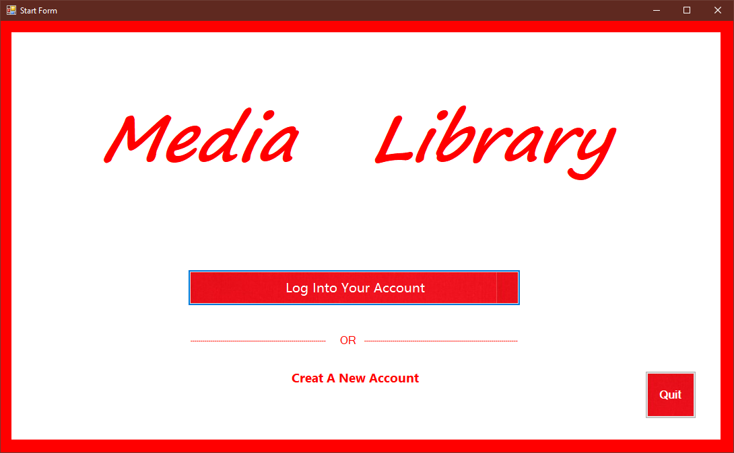Figure (1.1)

After Testing

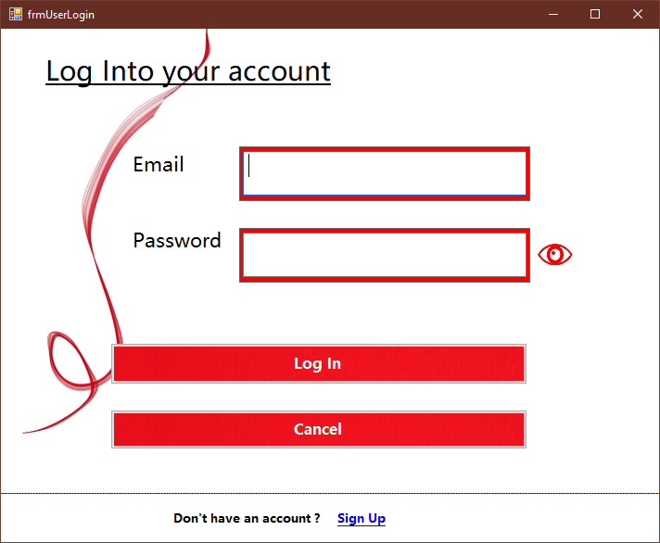

Figure 1.2

### Unit Testing

|  |  |
| --- | --- |
| Test Case | 2 |
| Form | Start.cs |
| Test Description | To check whether registration form is reached when create button is clicked |
| Test Procedure | Click create button |
| Expected Result | The log in form will appear |
| Actual Result | Shown in figure(2.1 & 2.2) |

Before Testing

Figure (2.1)

After testing

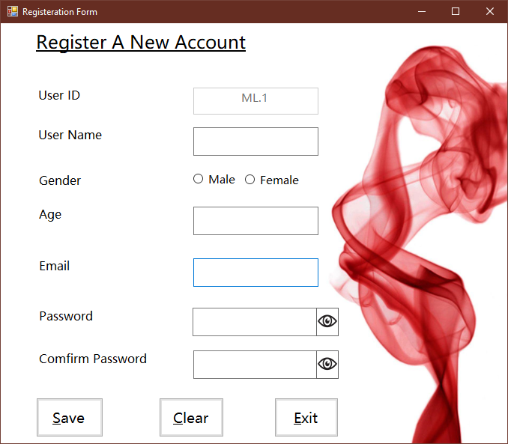

Figure (2.2)

### Unit Testing

|  |  |
| --- | --- |
| Test Case | 3 |
| Form | frmUserLogin.cs |
| Test Description | To check whether the message box is shown when the user does not fill the email |
| Test Procedure | Fill the password but not email |
| Expected Result | The message box will appear |
| Actual Result | Shown in figure(3.1 & 3.2) |

Before Testing

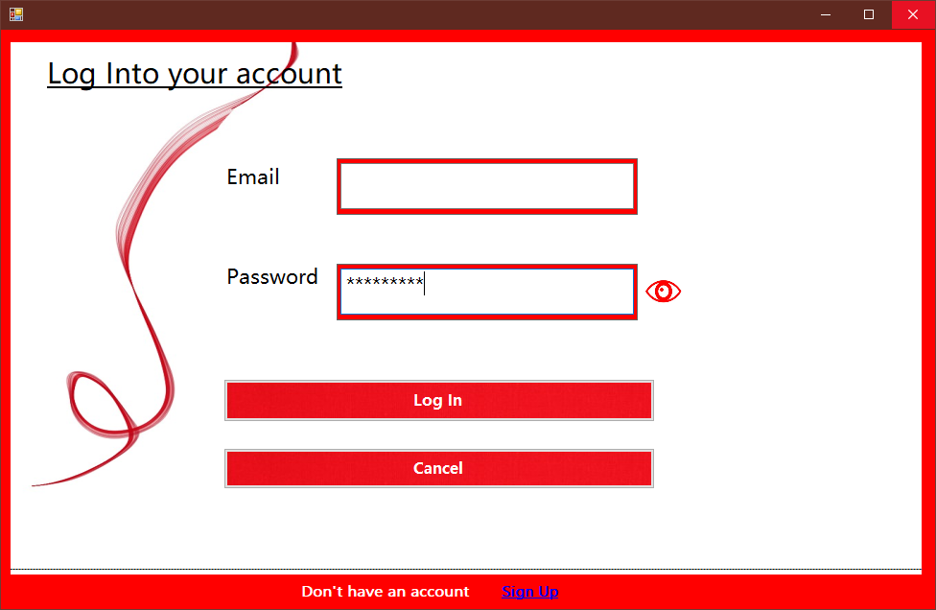

After Testing

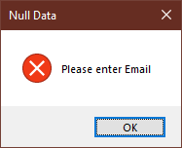

Figure (3.2)

### Unit Testing

|  |  |
| --- | --- |
| Test Case | 4 |
| Form | frmUserLogin.cs |
| Test Description | To check whether the message is shown when the password is not filled |
| Test Procedure | Input Email but not password and click Log In button |
| Expected Result | The message box will appear |
| Actual Result | Shown in figure(4.1 & 4.2) |

Before Testing

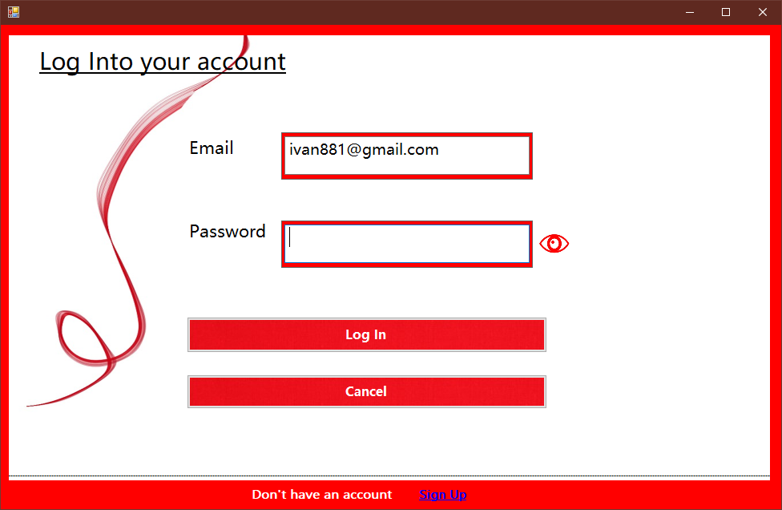Figure 4.1

After testing

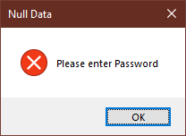

Figure (4.2)

### Unit Testing

|  |  |
| --- | --- |
| Test Case | 7 |
| Form | frmUserLogin.cs |
| Test Description | To check the function of cancel button |
| Test Procedure | Click cancel button |
| Expected Result | Close Log in form and reach start form |
| Actual Result | Shown in figure(7.1, 7.2) |

Before Testing

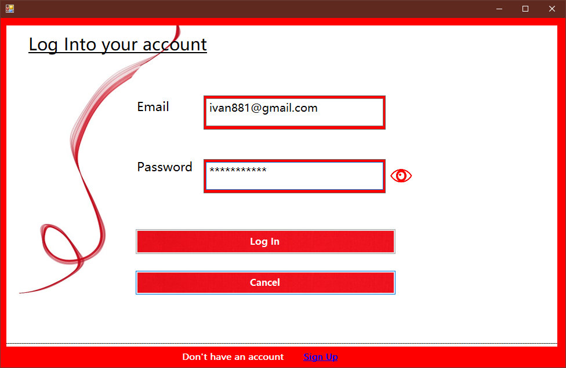Figure 7.1

### Unit Testing

|  |  |
| --- | --- |
| Test Case | 5 |
| Form | frmUserLogin.cs |
| Test Description | To check if the user input the incorrect email and password, the message box is shown |
| Test Procedure | Input wrong email or password and click Log In button |
| Expected Result | The message box will appear |
| Actual Result | Shown in figure(5.1 & 5.2 ) |

Before Testing

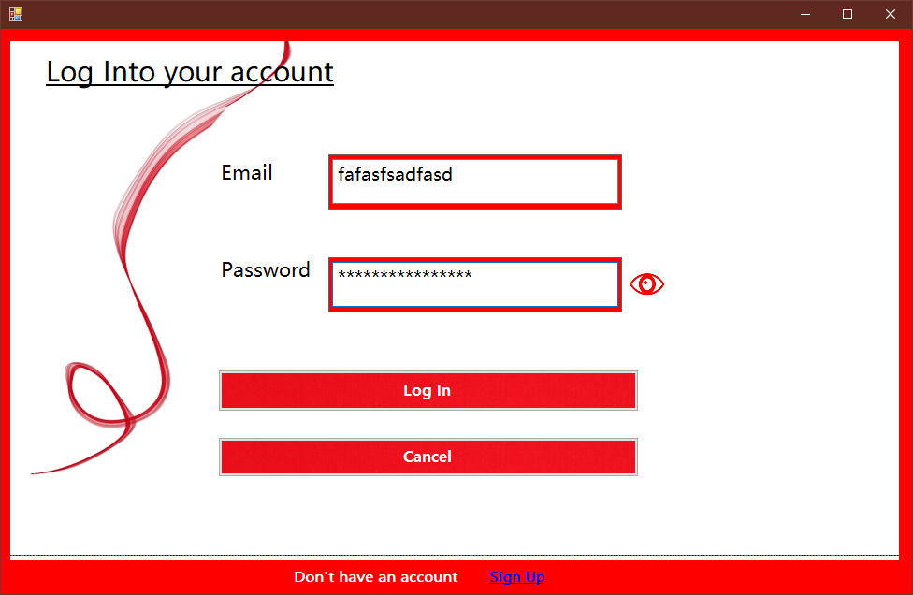Figure (5.1 )

After testing

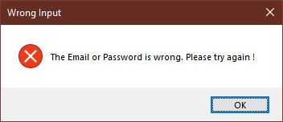

Figure ( 5.2 )

### Unit Testing

|  |  |
| --- | --- |
| Test Case | 6 |
| Form | frmUserLogin.cs |
| Test Description | To check if the user input the correct Email and password, the main form is reached |
| Test Procedure | Input correct email and password. Then click Log In button |
| Expected Result | The message is shown and the main form is reached |
| Actual Result | Shown in figure(6.1, 6.2 & 6.3) |

Before Testing

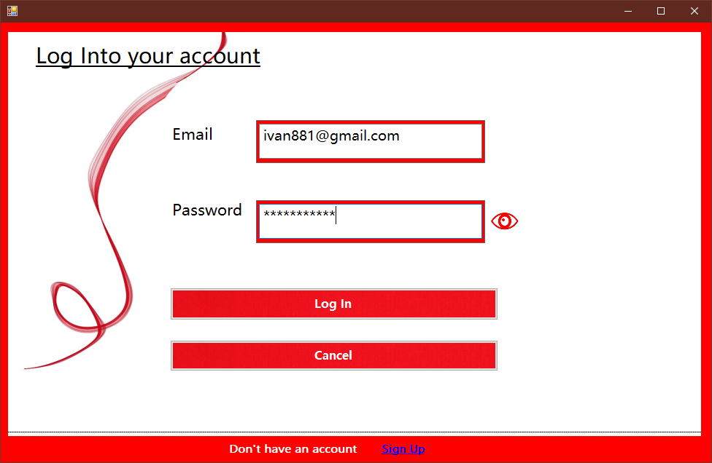Figure 6.1

After Testing

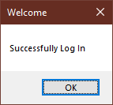

Figure 6.2

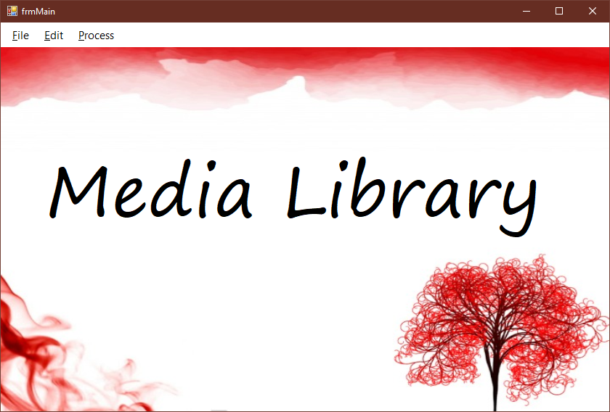

Figure 6.3

## After testing

## Figure 7.2

### Unit Testing

|  |  |
| --- | --- |
| Test Case | 8 |
| Form | frmUserLogin.cs |
| Test Description | To check whether registration form is reach when link label Sign Up is clicked |
| Test Procedure | Click link label Sign Up |
| Expected Result | Close log in form and reach Registration form |
| Actual Result | Shown in figure(8.1, 8.2) |

Before Testing

Figure 8.1

After Testing

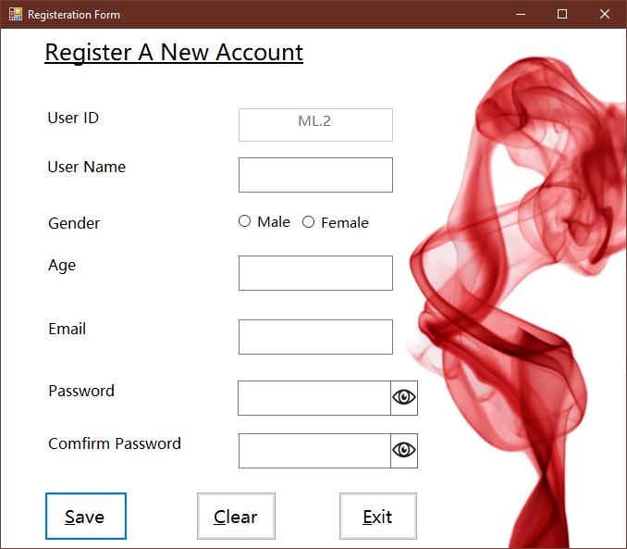

Figure 8.2

### Unit Testing

|  |  |
| --- | --- |
| Test Case | 9 |
| Form | User Login.cs |
| Test Description | To check whether the password character is changed when unhide picture is clicked |
| Test Procedure | Click the picture box unhide |
| Expected Result | Change the password character |
| Actual Result | Shown in figure(9.1, 9.2) |

Before Testing

## Figure 9.1

After testing

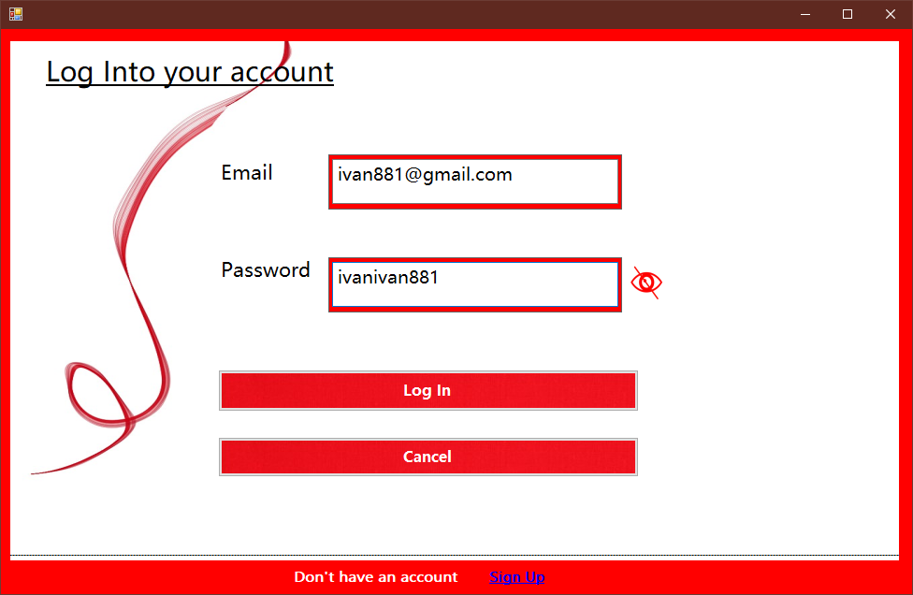Figure 9.2

### Unit Testing

|  |  |
| --- | --- |
| Test Case | 10 |
| Form | frmRegister.cs |
| Test Description | To check whether the message box is shown when the user name is not filled |
| Test Procedure | Not fill the user name while other text box are filled |
| Expected Result | Show the message box |
| Actual Result | Shown in figure (10.1 & 10.2) |

Before Testing

Figure 10.1

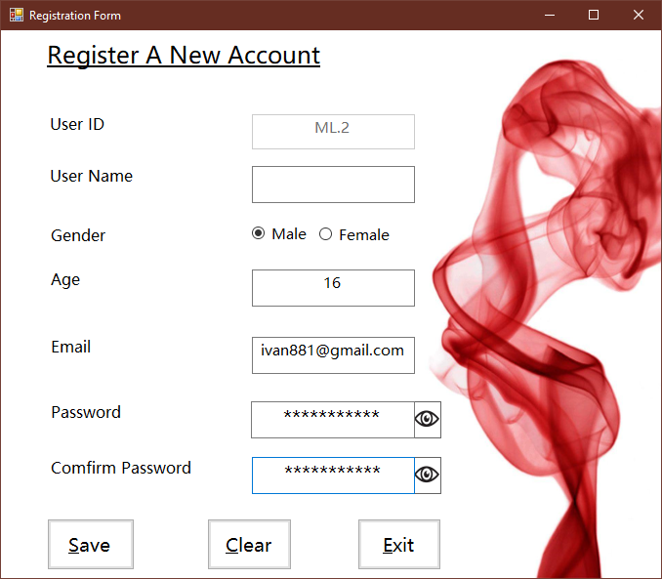

Figure 10.1

After testing

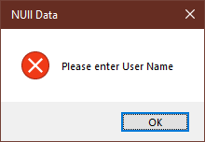

Figure 10.2

### Unit Testing

|  |  |
| --- | --- |
| Test Case | 11 |
| Form | frmRegister.cs |
| Test Description | To check whether the message box is shown when the age is not filled |
| Test Procedure | The age is not filled while other text boxes are filled |
| Expected Result | Show the message box |
| Actual Result | Shown in figure (11.1 & 11.2) |

Before Testing

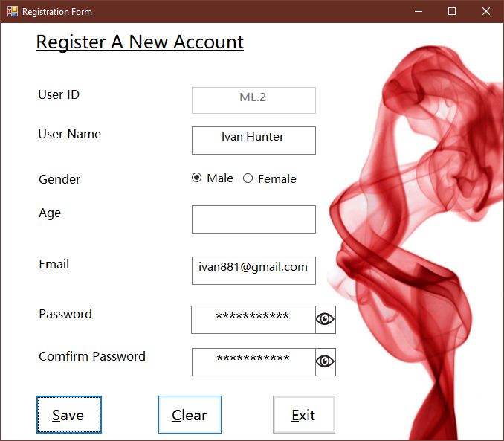

Figure 11.1

After testing

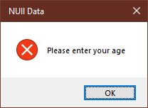

Figure 11.2

### Unit Testing

|  |  |
| --- | --- |
| Test Case | 12 |
| Form | frmRegister.cs |
| Test Description | To check whether the message box is shown when the Email is not filled |
| Test Procedure | The email is not filled while other text boxes are filled |
| Expected Result | Show the message box |
| Actual Result | Shown in figure (12.1 & 12.2) |

Before Testing

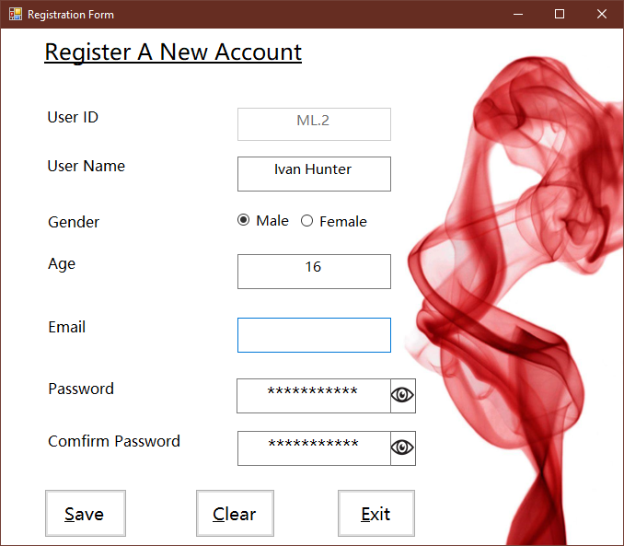

Figure 12.1

After testing

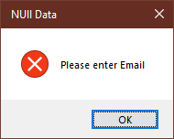

Figure 12.2

### Unit Testing

|  |  |
| --- | --- |
| Test Case | 13 |
| Form | frmRegister.cs |
| Test Description | To check whether the message box is shown when the password is not filled |
| Test Procedure | The password is not filled while other text boxes are filled |
| Expected Result | Show the message box |
| Actual Result | Shown in figure (13.1 & 13.2) |

Before Testing

## 

## Figure 13.1

After Testing

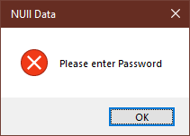

Figure 13.2

### Unit Testing

|  |  |
| --- | --- |
| Test Case | 14 |
| Form | frmRegister.cs |
| Test Description | To check whether the message box is shown when the password is not comfirmed |
| Test Procedure | The comfirm password is not filled while other text boxes are filled |
| Expected Result | Show the message box |
| Actual Result | Shown in figure (14.1 & 14.2) |

Before Testing

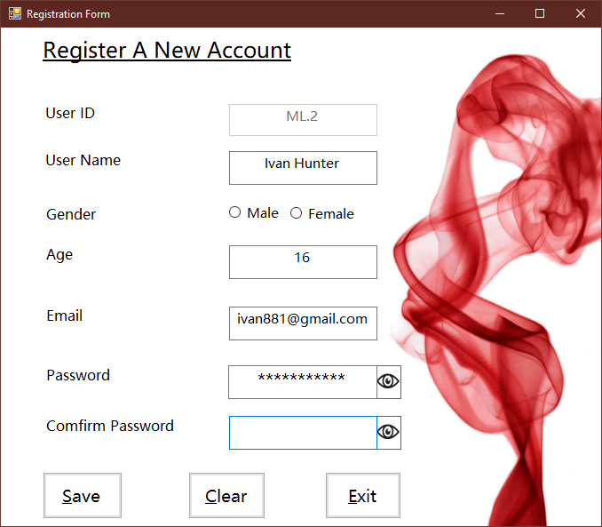

Figure 14.1

After Testing

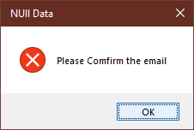

Figure 14.2

### Unit Testing

|  |  |
| --- | --- |
| Test Case | 14.1 |
| Form | frmRegister.cs |
| Test Description | To check whether the message box is shown when password character is less than eight |
| Test Procedure | Fill password less than 8 characters. |
| Expected Result | Show the message box |
| Actual Result | Shown in figure (14.1.1 & 14.1.2) |

Before Testing

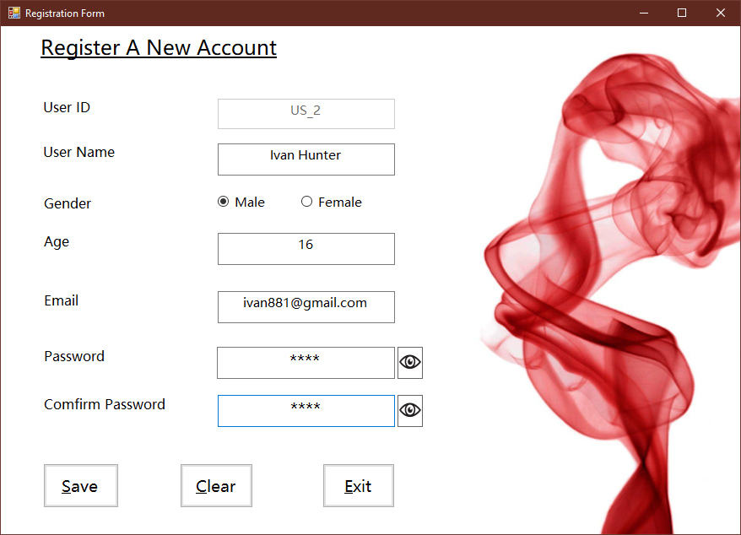

Figure 14.1.1

After Testing

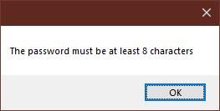

Figure 14.1.2

### Unit Testing

|  |  |
| --- | --- |
| Test Case | 15 |
| Form | frmRegister.cs |
| Test Description | To check whether the accounted is created and the main form is reached |
| Test Procedure | Fill all text box with correct data |
| Expected Result | Show the message box and reach main form |
| Actual Result | Shown in figure (15.1, 15.2 & 15.3) |

Before Testing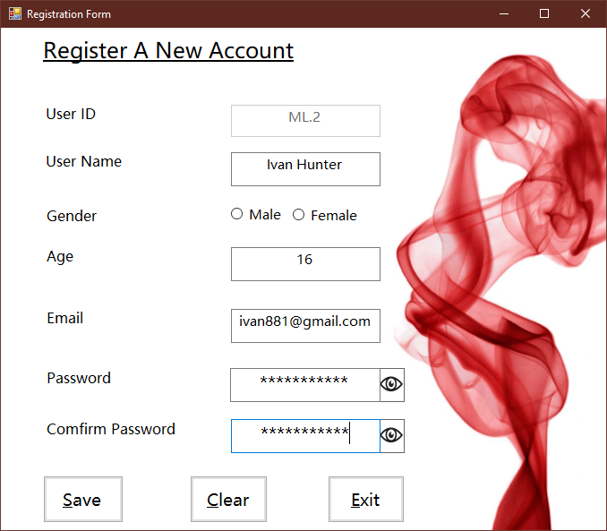Figure 15.1

After testing

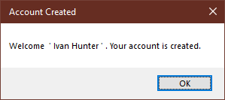

Figure 15.2

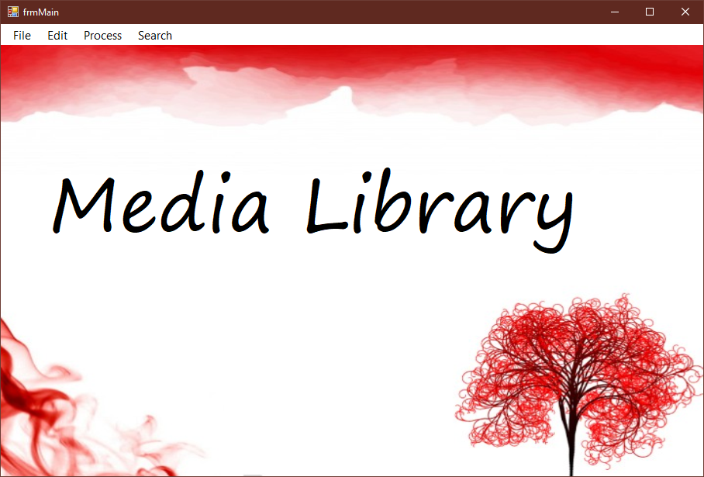

Figure 15.3

### Unit Testing

|  |  |
| --- | --- |
| Test Case | 15.1 |
| Form | frmRegister.cs |
| Test Description | To check whether the user ID is increased automatically after an account is registered |
| Test Procedure | Create an account and open the registration form again. |
| Expected Result | User ID is increased |
| Actual Result | Shown in figure (15.1.1 & 15.1.2) |

## Before Testing

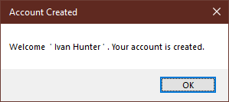

Figure 15.1.1

After Testing

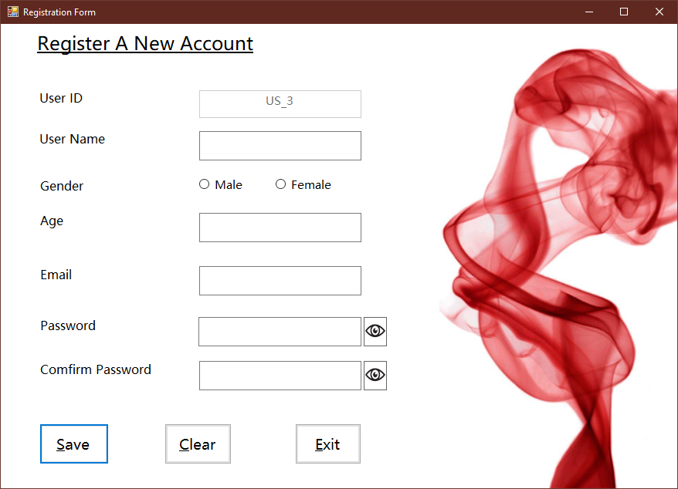

Figure 15.1.2

### Unit Testing

|  |  |
| --- | --- |
| Test Case | 16 |
| Form | frmRegister.cs |
| Test Description | To check whether the data are deleted when the clear button is clicked |
| Test Procedure | Fill all text box with data and click Clear button |
| Expected Result | Clear all the data. |
| Actual Result | Shown in figure (16.1 & 16.2) |

## Before Testing

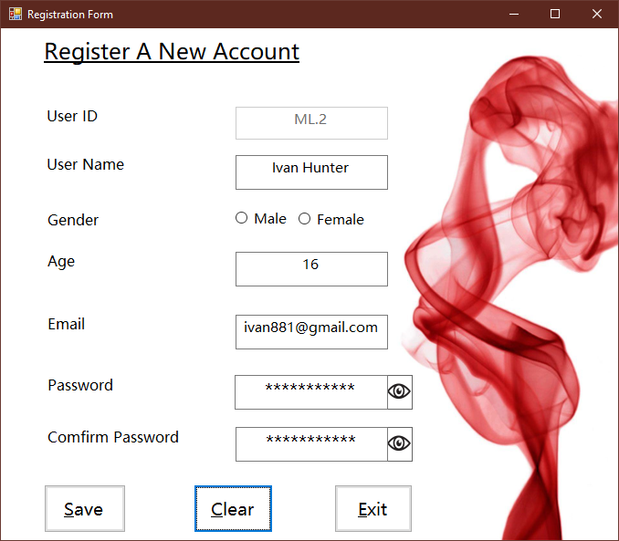Figure 16.1

After Testing

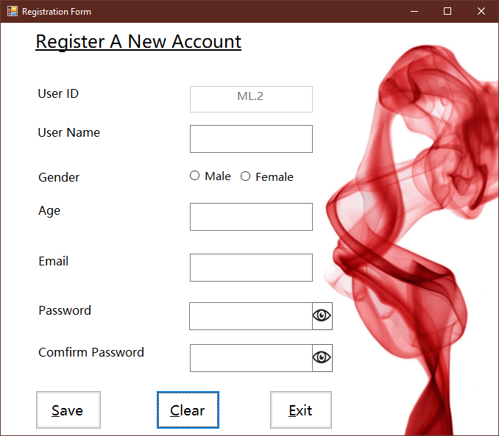Figure 16.2

### Unit Testing

|  |  |
| --- | --- |
| Test Case | 17 |
| Form | frmRegister.cs |
| Test Description | To check the function of exit button |
| Test Procedure | Click Exit button |
| Expected Result | Close frmregister and reach start form |
| Actual Result | Shown in figure (17.1 & 17.2) |

## Before Testing



Figure 17.1

After Testing

### 

### Figure 17.2

### Unit Testing

|  |  |
| --- | --- |
| Test Case | 18 |
| Form | frmMain.cs |
| Test Description | To check whether profile edit form is reached when “Profile Edit” is clicked. |
| Test Procedure | Click “Profile Edit” from tool strip menu |
| Expected Result | Close frmMain and reach frmProfileEdit |
| Actual Result | Shown in figure (18.1 & 18.2) |

Before Testing



Figure 18.1

*After Testing

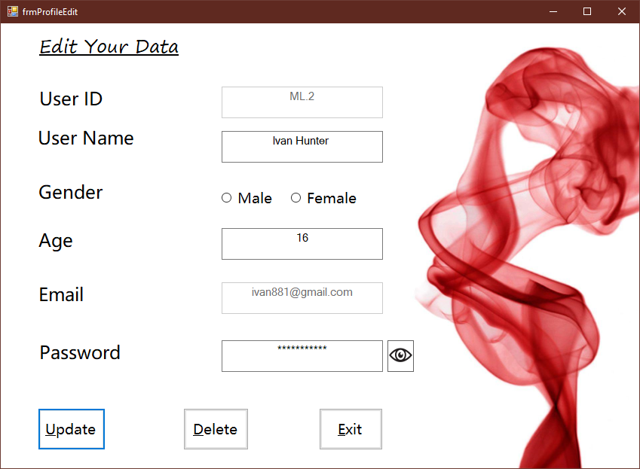  
Figure 18.2

### Unit Testing

|  |  |
| --- | --- |
| Test Case | 19 |
| Form | frmMain.cs |
| Test Description | To check whether Creating form is reached when “Create File” is clicked. |
| Test Procedure | Click “Create File” from Tools Strip Menu |
| Expected Result | Close frmMain and reach frmCreating |
| Actual Result | Shown in figure (19.1 & 19.2) |

Before Testing

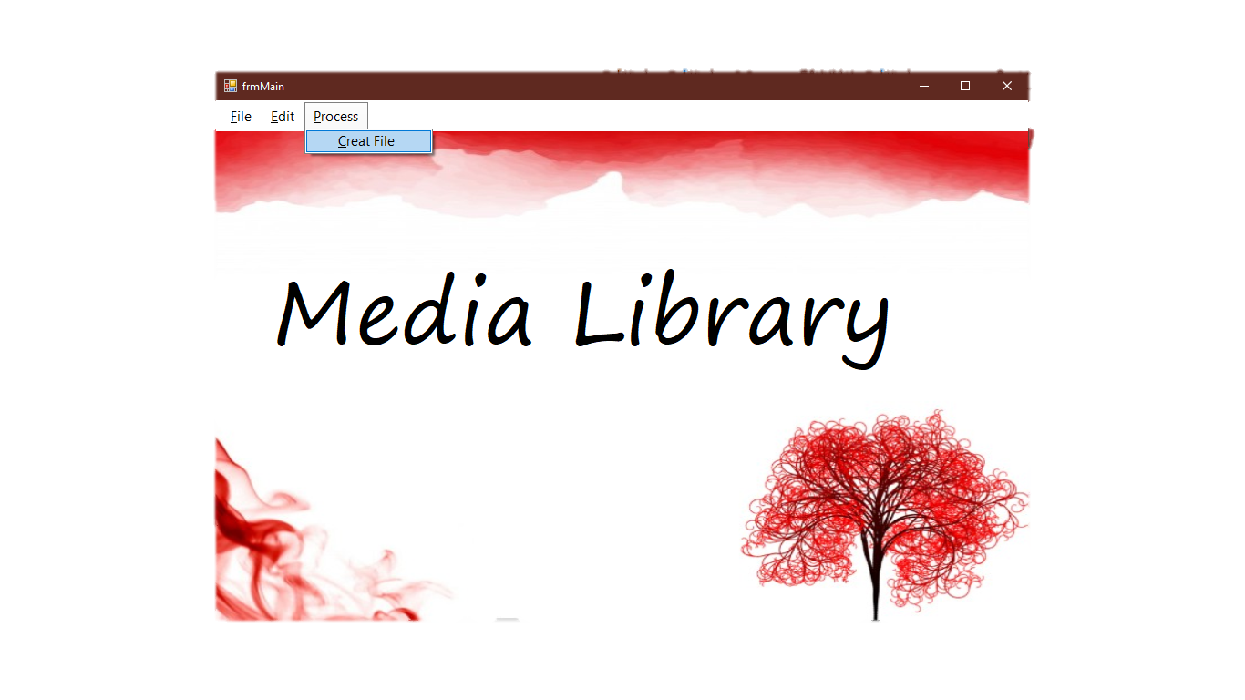

Figure 19.1

After Testing

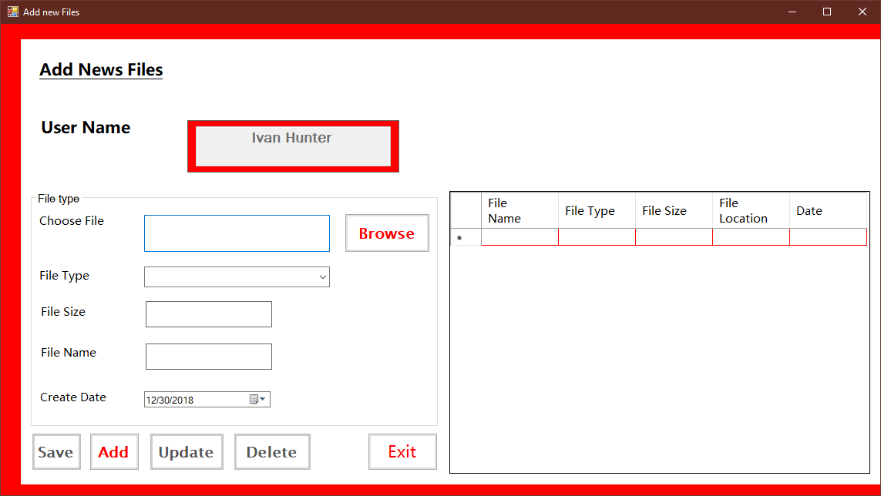

Figure 19.2

### Unit Testing

|  |  |
| --- | --- |
| Test Case | 20 |
| Form | frmProfileEdit.cs |
| Test Description | To check whether the message box is shown and the user name is updated when “update” button is click. |
| Test Procedure | Change User Name and click “Update” button |
| Expected Result | Message box is shown and user name is updated |
| Actual Result | Shown in figure (20.1, 20.2, 20.3 & 20.4) |

Before Testing



Figure 20.1

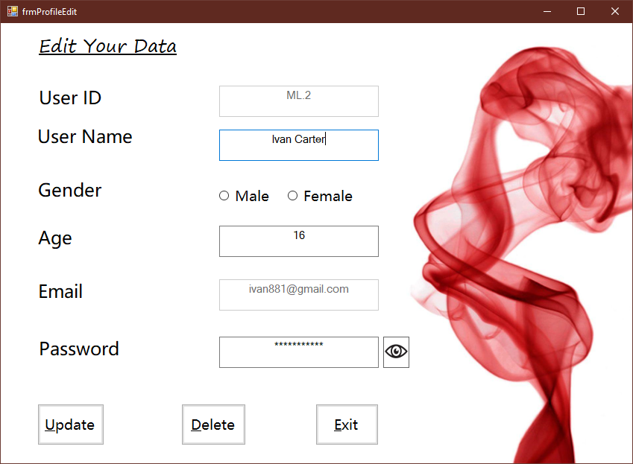

Figure 20.2

After Testing

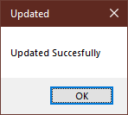

Figure 20.3

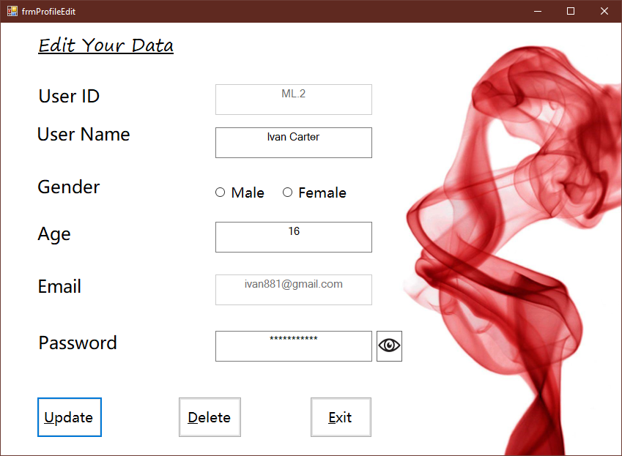

Figure 20.4

### Unit Testing

|  |  |
| --- | --- |
| Test Case | 21 |
| Form | frmProfileEdit.cs |
| Test Description | To check whether the edit form is close when Exit button is clicked |
| Test Procedure | Click “Exit” button. |
| Expected Result | Close Edit form and reached Main form |
| Actual Result | Shown in figure (21.1 and 21.2) |

Before Testing

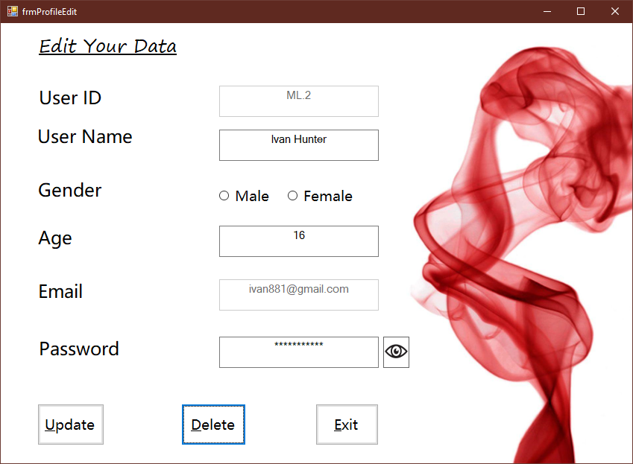

Figure 21.1

After Testing

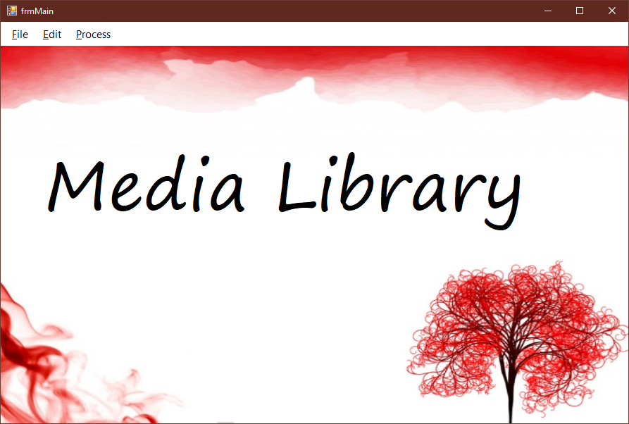

Figure 21.2

### Unit Testing

|  |  |
| --- | --- |
| Test Case | 22 |
| Form | frmProfileEdit.cs |
| Test Description | To check whether the data is delete when the “Delete” button is clicked |
| Test Procedure | Click “Delete” button. |
| Expected Result | Message box is shown and data are deleted |
| Actual Result | Shown in figure (22.1 and 22.2) |

Before Testing



Figure 22.1

After Testing

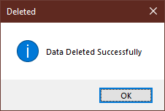

Figure 22.2

### Unit Testing

|  |  |
| --- | --- |
| Test Case | 23 |
| Form | frmMain.cs |
| Test Description | To check whether Create form is reached when “Create” is clicked from tool strip menu. |
| Test Procedure | Click “Process” from tool strip menu and click create |
| Expected Result | Create form is reached |
| Actual Result | Shown in figure (23.1 and 23.2) |

Before Testing



Figure 23.1

After testing

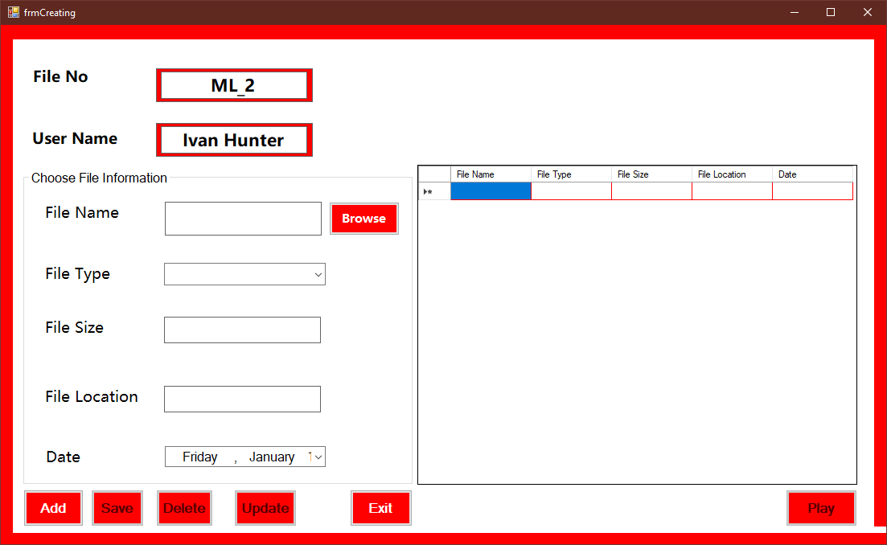

Figure 23.2

### Unit Testing

|  |  |
| --- | --- |
| Test Case | 24 |
| Form | frmCreating.cs |
| Test Description | To check whether message box is show when “Add” button is click without choosing a file |
| Test Procedure | Click “Add” button without choosing a file |
| Expected Result | Message box is shown |
| Actual Result | Shown in figure (24.1 and 24.2) |

Before Testing



Figure 24.1

After Testing

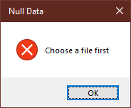

Figure 24.2

### Unit Testing

|  |  |
| --- | --- |
| Test Case | 25 |
| Form | frmCreating.cs |
| Test Description | To check whether message box is show when “Add” button is click without choosing file type |
| Test Procedure | Click “Add” button without choosing file type |
| Expected Result | Message box is shown |
| Actual Result | Shown in figure (25.1 and 25.2) |

Before Testing

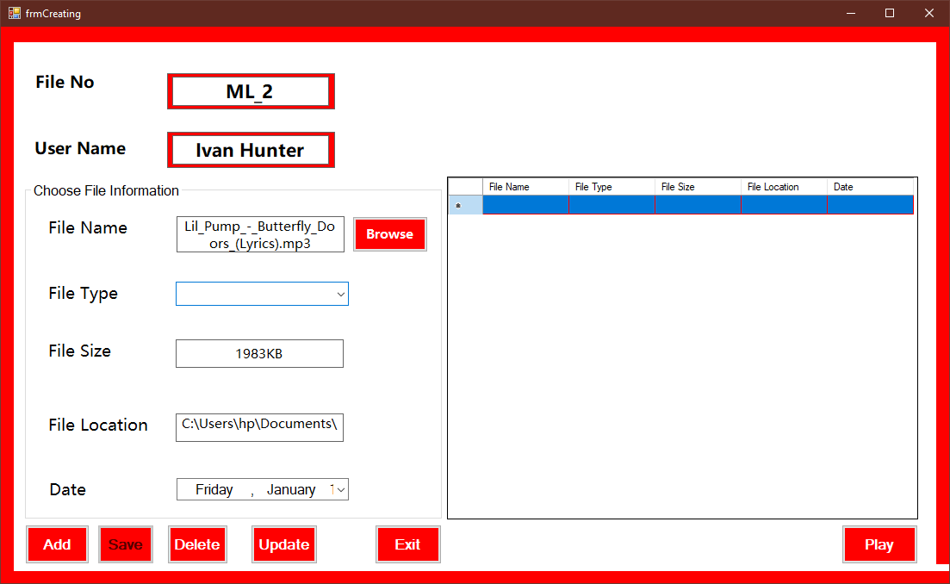

Figure 25.1

After Testing

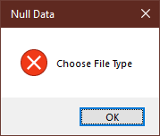

Figure 25.2

### Unit Testing

|  |  |
| --- | --- |
| Test Case | 26 |
| Form | frmCreating.cs |
| Test Description | To check whether data are added to the grid view and save button is enable when “Add” button is clicked with correct data. |
| Test Procedure | Browse file and choose file type. Then click “Add” button |
| Expected Result | Save button is enabled and data are added to the grid view |
| Actual Result | Shown in figure (26.1 and 26.2) |

Before Testing

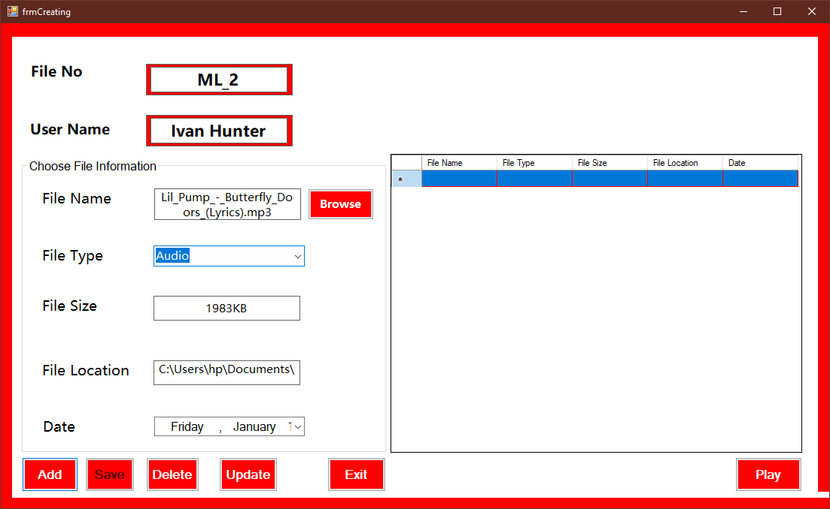

Figure 26.1

After Testing

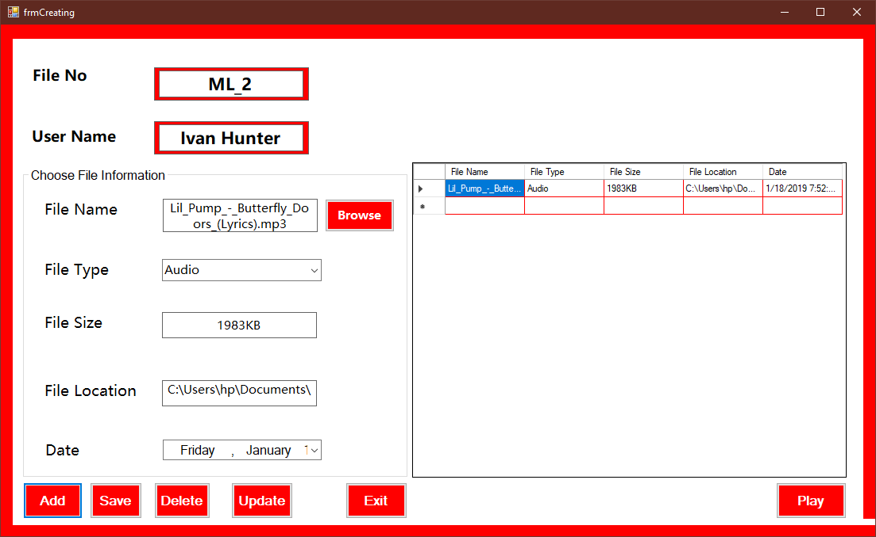

Figure 26.2

### Unit Testing

|  |  |
| --- | --- |
| Test Case | 27 |
| Form | frmCreating.cs |
| Test Description | To check whether open file dialogue is shown and data information are chosen when click at “Browse” button and choose a file |
| Test Procedure | Click at “Browse” and choose a file. |
| Expected Result | Open file dialogue is shown |
| Actual Result | Shown in figure (27.1, 27.2 and 27.3) |

Before testing

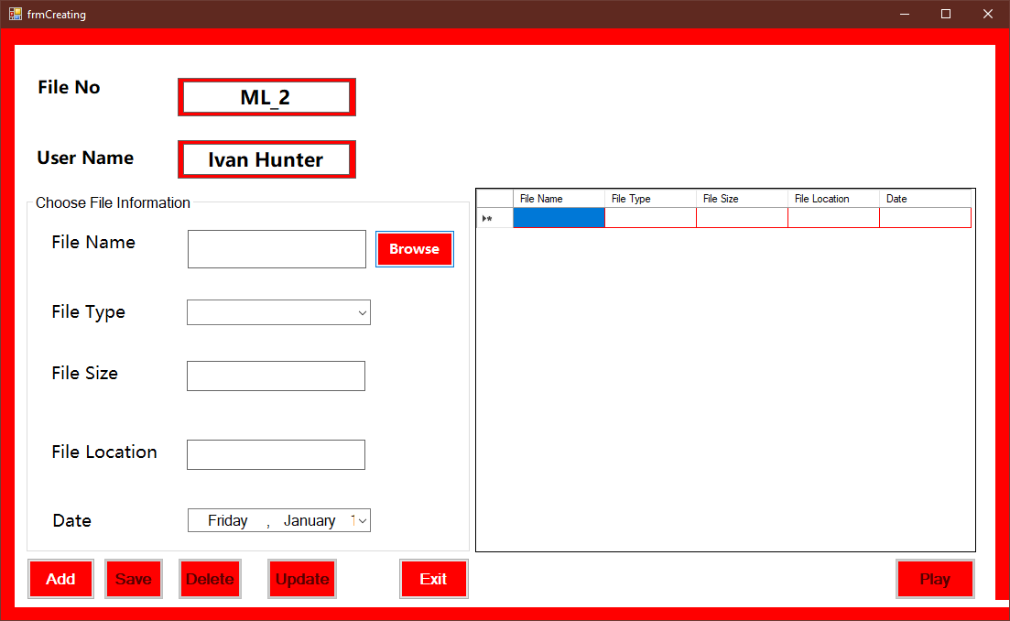

Figure 27.1

After testing

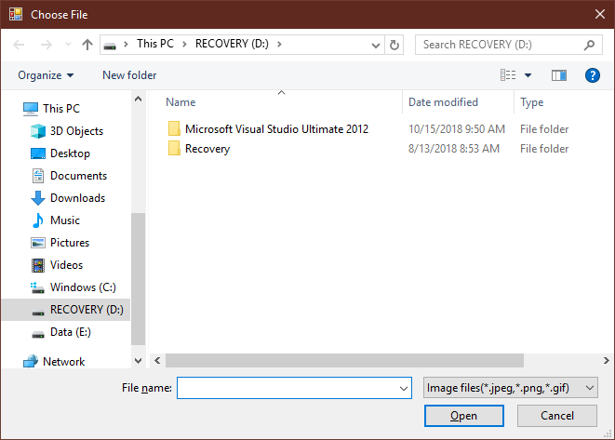

Figure 27.2

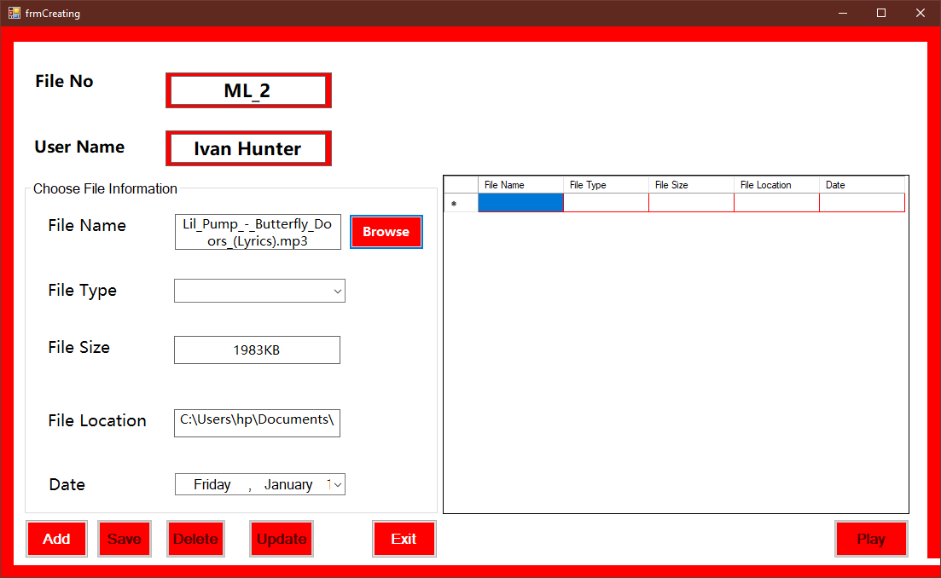

Figure 27.3

### Unit Testing

|  |  |
| --- | --- |
| Test Case | 28 |
| Form | frmCreating.cs |
| Test Description | To check whether data are saved and message box is shown when save button is click |
| Test Procedure | Add data to the grid and click :Save” button. |
| Expected Result | Message box is shown and data are saved |
| Actual Result | Shown in figure (28.1 and 28.2) |

Before Testing

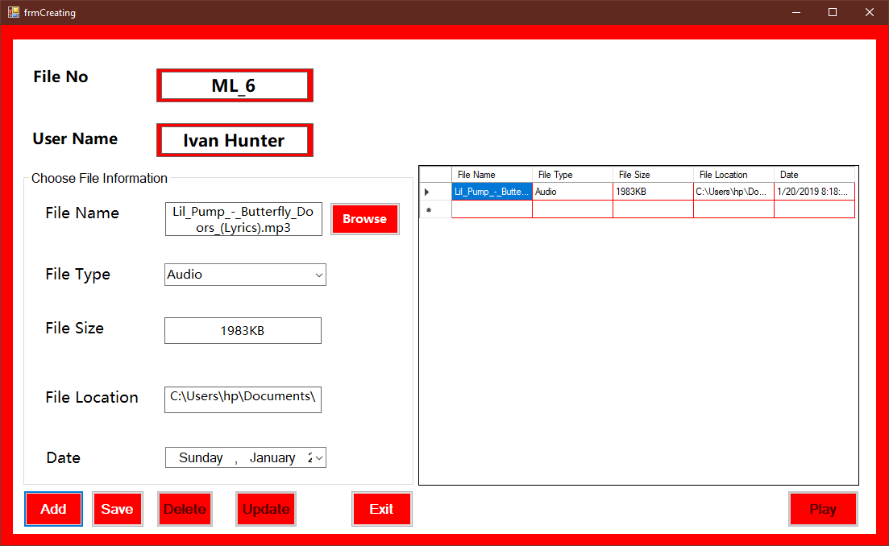

Figure 28.1

After testing

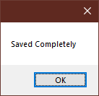

Figure 28.2

### Unit Testing

|  |  |
| --- | --- |
| Test Case | 29 |
| Form | frmCreating.cs |
| Test Description | To check whether “Update” button, “Play” button and “Delete” are enable when the cell of the grid is clicked. |
| Test Procedure | Click the cells of the grid. |
| Expected Result | Update button, play button and delete button are enabled. |
| Actual Result | Shown in figure (29.1 and 29.2) |

Before Testing

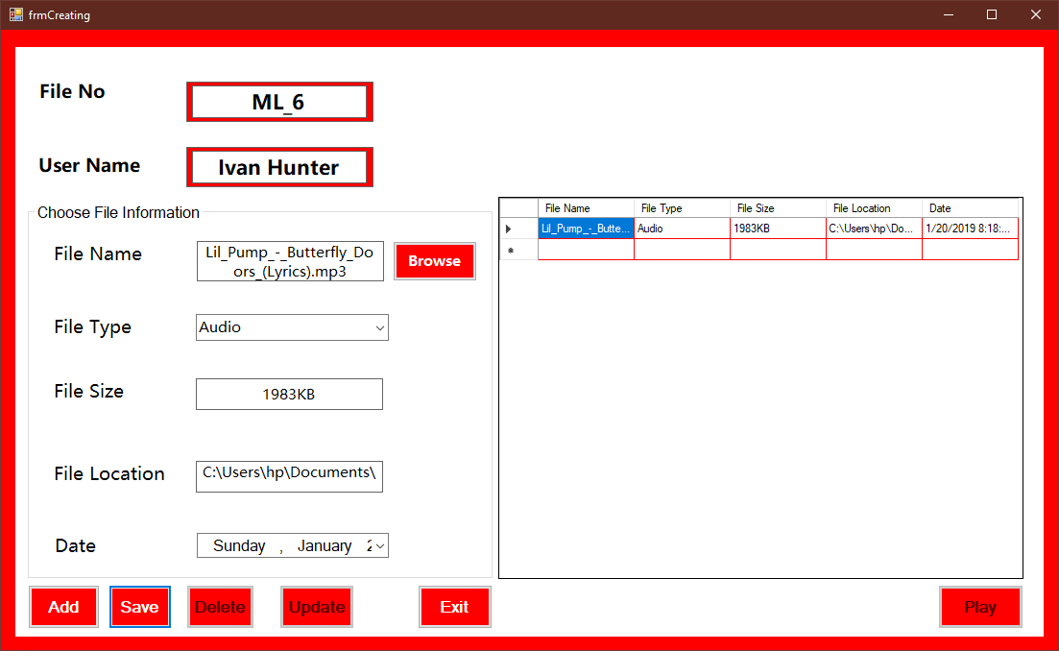

Figure 29.1

After Testing

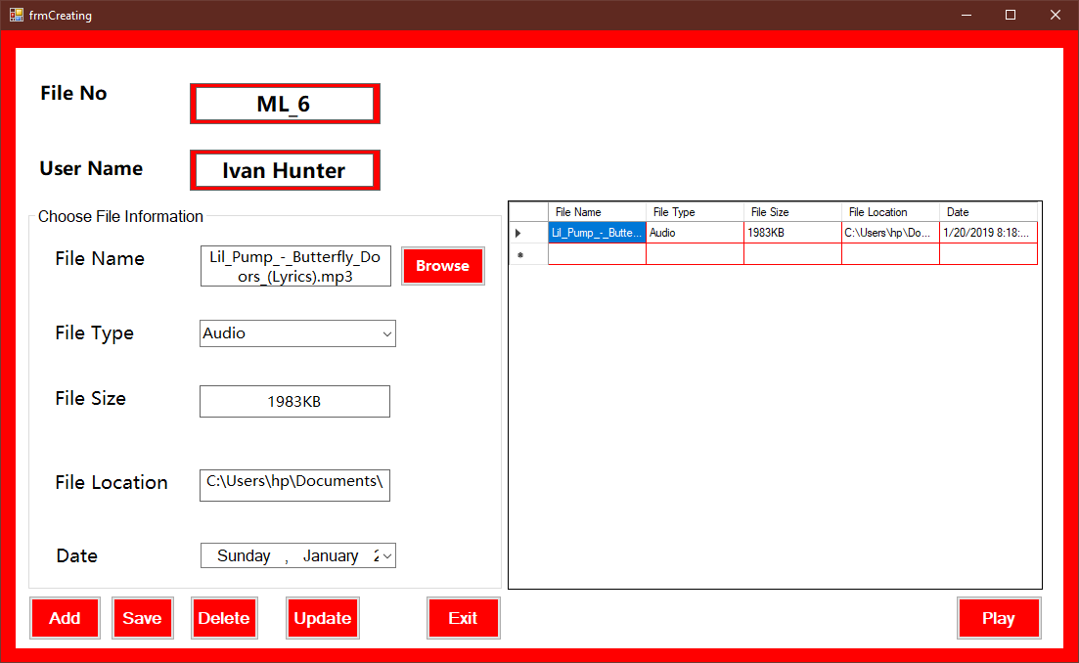

Figure 29.2

### Unit Testing

|  |  |
| --- | --- |
| Test Case | 30 |
| Form | frmCreating.cs |
| Test Description | To check whether message box is shown and the data are updated when “Update” is clicked |
| Test Procedure | Retype the data and click the “Update” button |
| Expected Result | Message box is shown and Data are updated. |
| Actual Result | Shown in figure (30.1 and 30.2) |

Before Testing

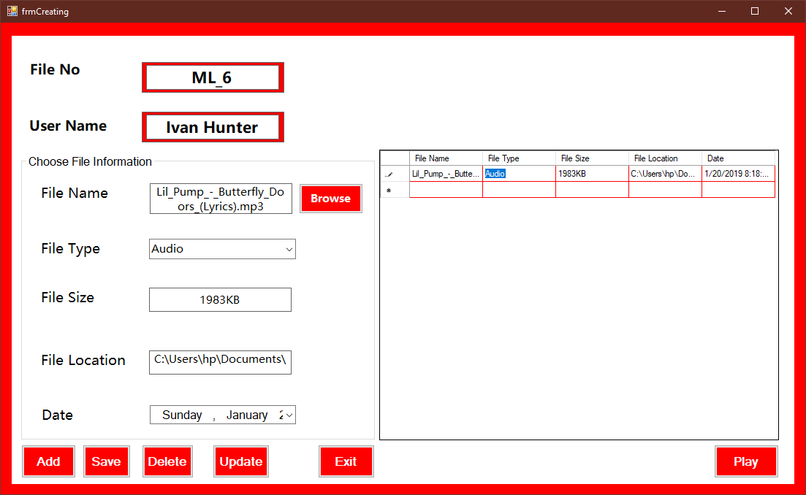

Figure 30.1

After Testing

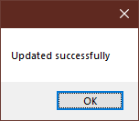

Figure 30.2

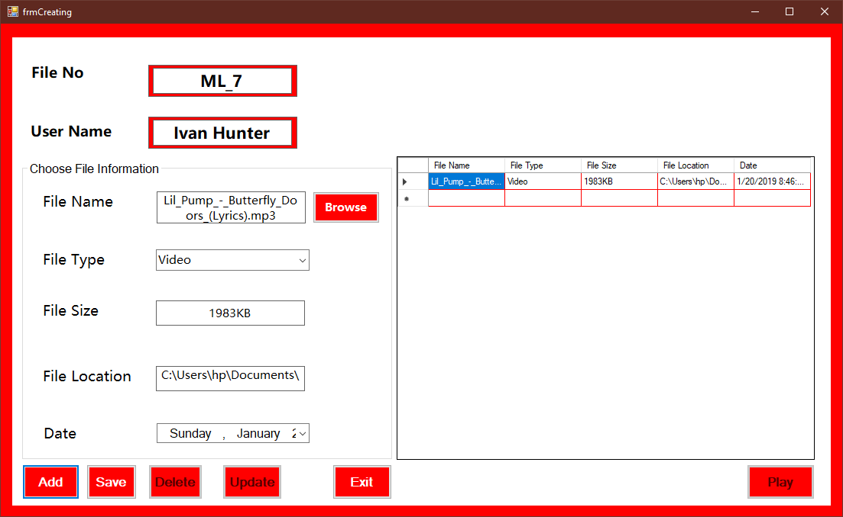

Figure 30.3

### Unit Testing

|  |  |
| --- | --- |
| Test Case | 31 |
| Form | frmCreating.cs |
| Test Description | To check whether message box is shown and the data are deleted when “Delete” is clicked |
| Test Procedure | Click “Delete” button |
| Expected Result | Message box is shown and Data are deleted |
| Actual Result | Shown in figure (31.1 and 31.2) |

Before Testing

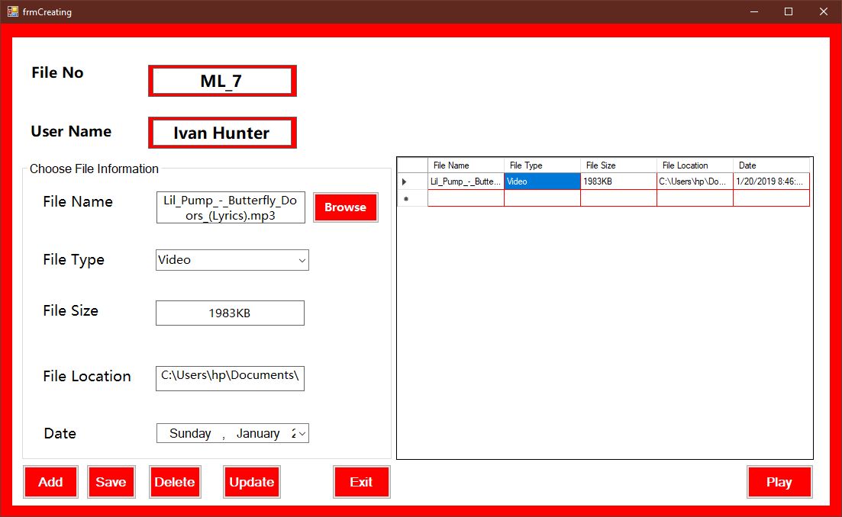

Figure 31.1

After Testing

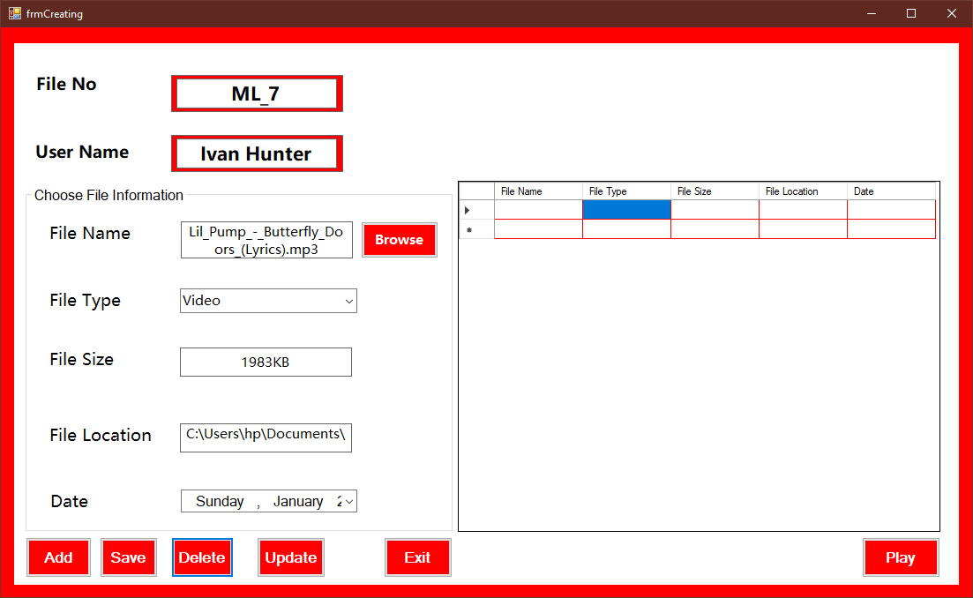

Figure 31.2

### Unit Testing

|  |  |
| --- | --- |
| Test Case | 32 |
| Form | frmCreating.cs |
| Test Description | To check whether the media file is played when “Play” button is clicked |
| Test Procedure | Choose a file and click “Play” button |
| Expected Result | The media file is played. |
| Actual Result | Shown in figure (32.1 and 32.2) |

Before Testing

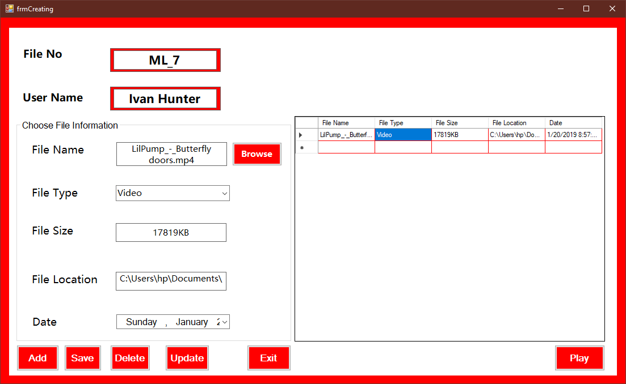

Figure 32.1

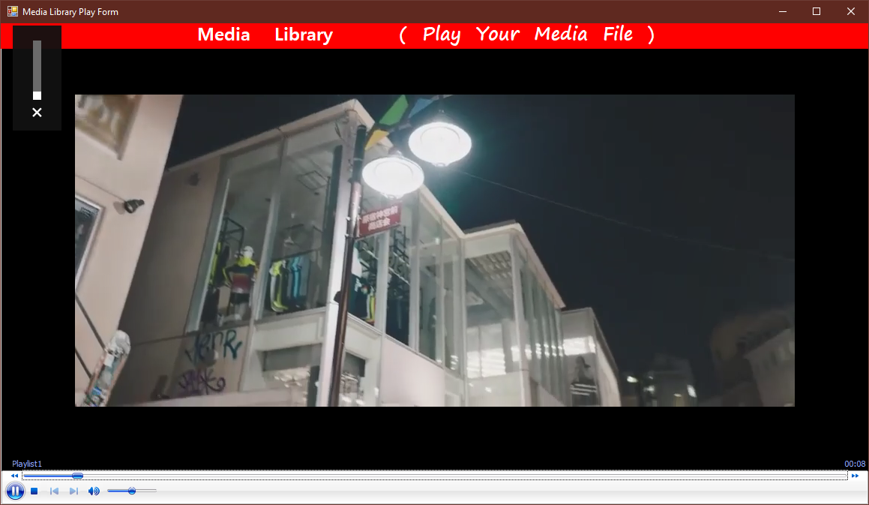

Figure 32.2

### Unit Testing

|  |  |
| --- | --- |
| Test Case | 33 |
| Form | frmSearching.cs |
| Test Description | To check whether all the media file are shown when “Show All Files” button is clicked |
| Test Procedure | Click “Show All Files” button |
| Expected Result | All media files are shown in the grid |
| Actual Result | Shown in figure (33.1 and 33.2) |

Before Testing

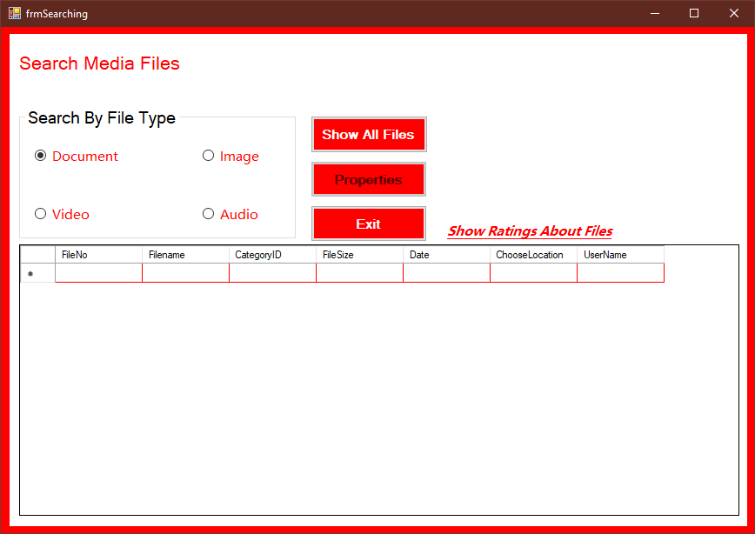

Figure 33.1

After Testing

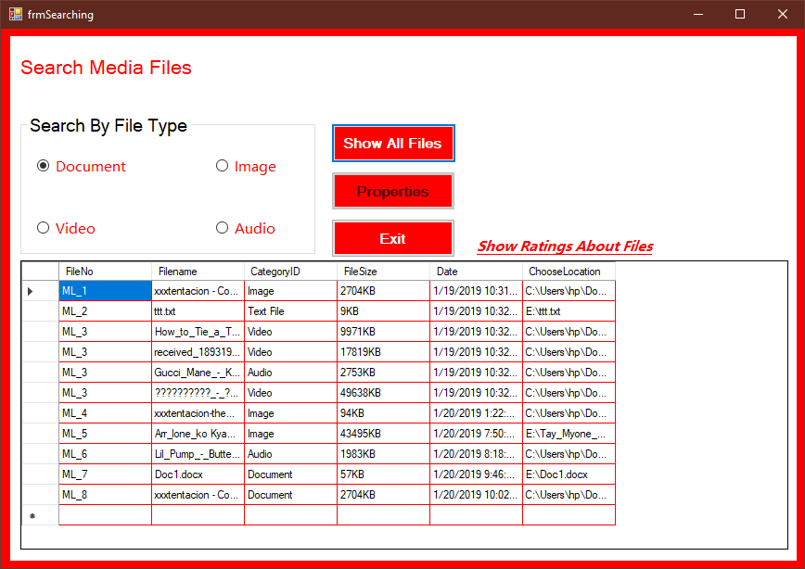

Figure 33.2

### Unit Testing

|  |  |
| --- | --- |
| Test Case | 34 |
| Form | frmSearching.cs |
| Test Description | To check whether audio files are shown when “Audio” is check |
| Test Procedure | Check “Audiio” Radio button |
| Expected Result | Audio files are shown in the grid |
| Actual Result | Shown in figure (34.1 and 34.2) |

Before Testing

Figure 34.1

After Testing

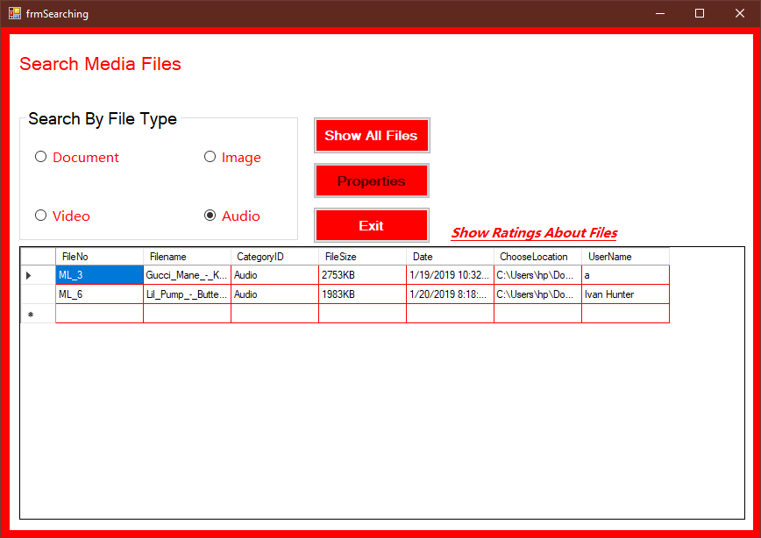

Figure 34.2

### Unit Testing

|  |  |
| --- | --- |
| Test Case | 35 |
| Form | frmSearching.cs |
| Test Description | To check whether Video files are shown when “Video” is check |
| Test Procedure | Check “Video” Radio button |
| Expected Result | Video files are shown in the grid |
| Actual Result | Shown in figure (35.1 and 35.2) |

Before Testing



Figure 35.1

After Testing

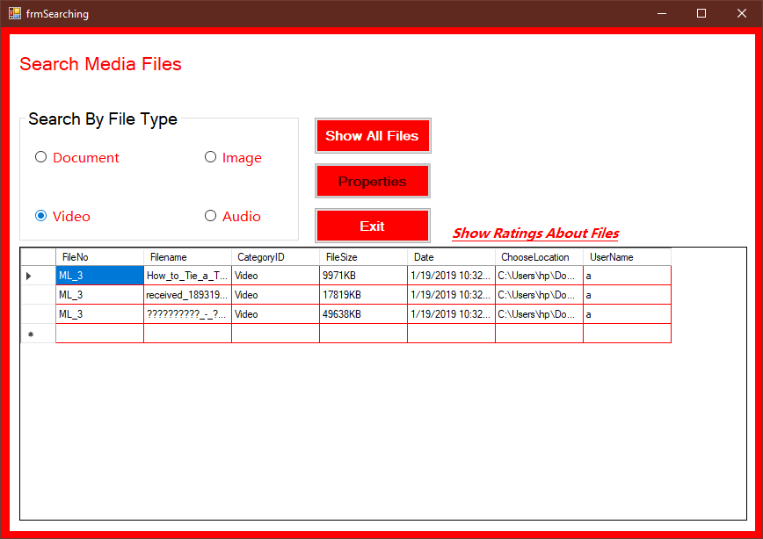

Figure 35.2

### Unit Testing

|  |  |
| --- | --- |
| Test Case | 36 |
| Form | frmSearching.cs |
| Test Description | To check whether Image files are shown when “Image” is checked |
| Test Procedure | Check “Image” Radio button |
| Expected Result | Image files are shown in the grid |
| Actual Result | Shown in figure (36.1 and 36.2) |

Before Testing

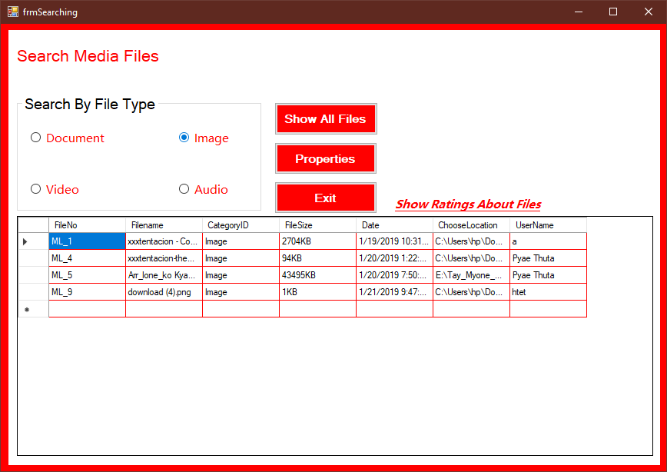

Figure 36.1

After Testing

Figure 36.2

### Unit Testing

|  |  |
| --- | --- |
| Test Case | 37 |
| Form | frmSearching.cs |
| Test Description | To check whether “Properties” button is enabled when cell of the grid is clicked |
| Test Procedure | Click the cell of the grid |
| Expected Result | Properties button is enabled |
| Actual Result | Shown in figure (37.1 and 37.2) |

Before Testing

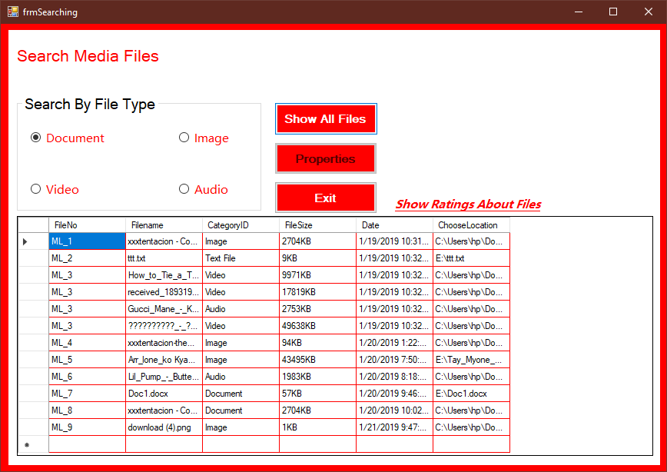

Figure 37.1

After Testing

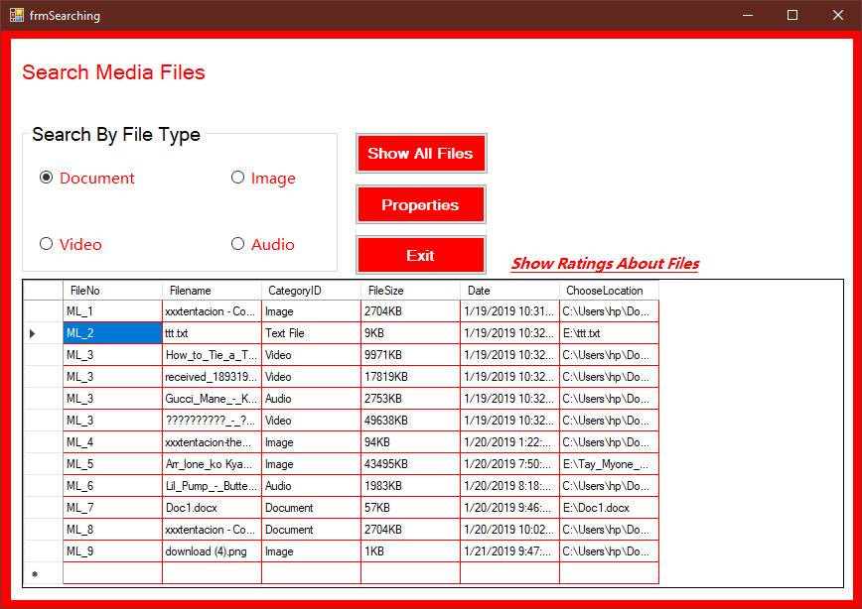

Figure 37.2

### Unit Testing

|  |  |
| --- | --- |
| Test Case | 38 |
| Form | frmSearching.cs |
| Test Description | To check whether “Properties form” is shown when Properties button is clicked |
| Test Procedure | Click the “Properties” button. |
| Expected Result | Properties form is shown with correct information |
| Actual Result | Shown in figure (38.1 and 38.2) |

Before Testing



Figure 38.1

After Testing

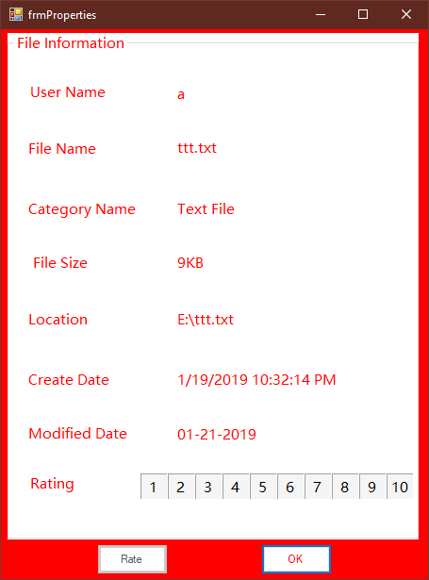

Figure 38.2

### Unit Testing

|  |  |
| --- | --- |
| Test Case | 39 |
| Form | frmProperties.cs |
| Test Description | To check whether the message box is shown and the file is rated when rate button is clicked |
| Test Procedure | Choose a rating level and click “Rated” button. |
| Expected Result | The message box is shown and the media file is rate. |
| Actual Result | Shown in figure (39.1, 39.2 and 39.3) |

Before Testing



Figure 39.1

After Testing

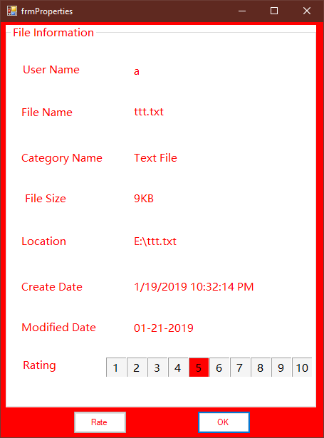

Figure 39.2

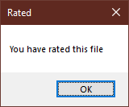

Figure 39.3

### Unit Testing

|  |  |
| --- | --- |
| Test Case | 40 |
| Form | frmSearching.cs |
| Test Description | To check whether the rating form is shown and the rating about files are shown when “Show Rating” link label is clicked |
| Test Procedure | Click link label “Show rating about files” |
| Expected Result | Rating form is shown with the data |
| Actual Result | Shown in figure (40.1 and 40.2) |

Before Testing

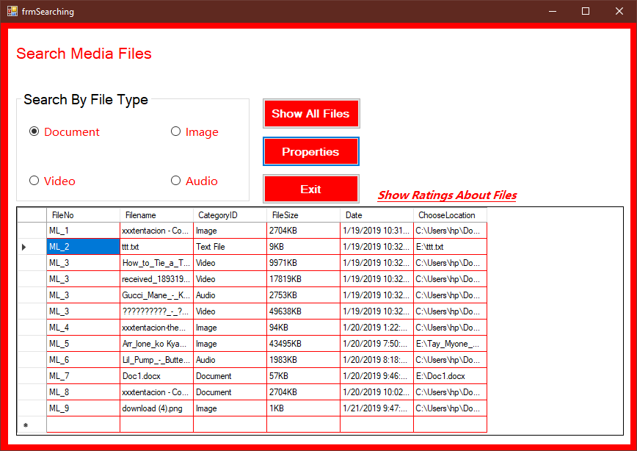

Figure 40.1

After testing

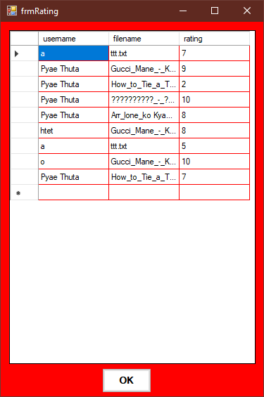

Figure 40.2

## White Box Testing

1. private void btnSave_Click(object sender, EventArgs e)
2. {
3. DataTable d = new DataTable();
4. d = f.GetData();
5. fd.Insert(txtFileNo.Text, userid);
6. for (int i = 0; i < dgvAdd.Rows.Count - 1; i++)
7. {
8. string name = dgvAdd.Rows[i].Cells[0].Value.ToString();
9. string type = dgvAdd.Rows[i].Cells[1].Value.ToString();
10. string size = dgvAdd.Rows[i].Cells[2].Value.ToString();
11. string location = dgvAdd.Rows[i].Cells[3].Value.ToString();
12. string date = dgvAdd.Rows[i].Cells[4].Value.ToString();
13. f.Insert(txtFileNo.Text, name, type, size, date, location);
14. MessageBox.Show(" Saved Completely");
15. }
16. }

|  |  |  |  |
| --- | --- | --- | --- |
| Line No. | Variables | Condition | Output |
| 6 |  | int i = 0; i < dgvAdd.Rows.Count - 1; i++) |  |
| 8 | name = Jaden Smith­_Plastic_lyrics video |  |  |
| 9 | type = Vidoe |  |  |
| 10 | size = 11328KB |  |  |
| 11 | location =  C:\Users\hp\Downloads\thumb-350-938132.png |  |  |
| 12 | Date =  1/21/2019 8:51:12 PM |  |  |
|  |  |  | Saved Completely |

## Integration test script

##### Integration Testing

|  |  |
| --- | --- |
| Test Case | 1 |
| Form | frmStart.cs |
| Test Description | To check whether the log in form is shown when “Log IN” is clicked |
| Test Procedure | Click “Log In “ Button |
| Expected Result | Log in form is shown |
| Actual Result | Shown in figure (1.1 &1.2) |

Before Testing

Figure (1.1)

After Testing



Figure 1.2

##### Integration Testing

|  |  |
| --- | --- |
| Test Case | 2 |
| Form | frmUserLogin.cs |
| Test Description | To check whether the account is logged in when “Log In” button is clicked with correct email and password |
| Test Procedure | Click “Log In “ Button with correct email and password in the text boxes |
| Expected Result | Message box is shown and log in is successfully |
| Actual Result | Shown in figure (2.1, 2.2 |

Before Testing

Figure 2.1

After Testing



Figure 2.2



Figure 2.3

##### Integration Testing

|  |  |
| --- | --- |
| Test Case | 3 |
| Form | frmRegister.cs |
| Test Description | To check whether the accounted is created and the main form is reached when “Save” button is clicked with correct data |
| Test Procedure | Fill all text box with correct data and click “Save” button |
| Expected Result | Show the message box and reach main form |
| Actual Result | Shown in figure (3.1, 3.2 & 3.3) |

Before TestingFigure 3.1

After testing



Figure3.2



Figure3.3

##### Integration Testing

|  |  |
| --- | --- |
| Test Case | 4 |
| Form | frmMain.cs |
| Test Description | To check whether profile edit form is reached when “Profile Edit” is clicked. |
| Test Procedure | Click “Profile Edit” from tool strip menu |
| Expected Result | Close frmMain and reach frmProfileEdit |
| Actual Result | Shown in figure (4.1 & 4.2) |

Before Testing



Figure 4.1

*After Testing

  
Figure 4.2

##### Integration Testing

|  |  |
| --- | --- |
| Test Case | 5 |
| Form | frmMain.cs |
| Test Description | To check whether Create form is reached when “Create” is clicked from tool strip menu. |
| Test Procedure | Click “Process” from tool strip menu and click create |
| Expected Result | Create form is reached |
| Actual Result | Shown in figure (5.1 and 5.2) |

Before Testing



Figure 5.1

After testing



Figure 5.2

##### Integration Testing

|  |  |
| --- | --- |
| Test Case | 6 |
| Form | frmCreating.cs |
| Test Description | To check whether data are added to the grid view and save button is enable when “Add” button is clicked with correct data. |
| Test Procedure | Browse file and choose file type. Then click “Add” button |
| Expected Result | Save button is enabled and data are added to the grid view |
| Actual Result | Shown in figure (6.1 and 6.2) |

Before Testing



Figure 6.1

After Testing



Figure 6.2

##### Integration Testing

|  |  |
| --- | --- |
| Test Case | 7 |
| Form | frmCreating.cs |
| Test Description | To check whether data are saved and message box is shown when save button is click |
| Test Procedure | Add data to the grid and click :Save” button. |
| Expected Result | Message box is shown and data are saved |
| Actual Result | Shown in figure (7.1 and 7.2) |

Before Testing



Figure 7.1

After testing



Figure 7.2

##### Integration Testing

|  |  |
| --- | --- |
| Test Case | 8 |
| Form | frmCreating.cs |
| Test Description | To check whether the media file is played when “Play” button is clicked |
| Test Procedure | Choose a file and click “Play” button |
| Expected Result | The media file is played. |
| Actual Result | Shown in figure (8.1 and 8.2) |

Before Testing



Figure 8.1



Figure 8.2

##### Integration Testing

|  |  |
| --- | --- |
| Test Case | 9 |
| Form | frmSearching.cs |
| Test Description | To check whether all the media file are shown when “Show All Files” button is clicked |
| Test Procedure | Click “Show All Files” button |
| Expected Result | All media files are shown in the grid |
| Actual Result | Shown in figure (9.1 and 9.2) |

Before Testing



Figure 9.1

After Testing



Figure 9.2

##### Integration Testing

|  |  |
| --- | --- |
| Test Case | 10 |
| Form | frmSearching.cs |
| Test Description | To check whether “Properties form” is shown when Properties button is clicked |
| Test Procedure | Click the “Properties” button. |
| Expected Result | Properties form is shown with correct information |
| Actual Result | Shown in figure (10.1 and 10.2) |

Before Testing



Figure 10.1

After Testing



Figure 10.2

##### Integration Testing

|  |  |
| --- | --- |
| Test Case | 11 |
| Form | frmProperties.cs |
| Test Description | To check whether the message box is shown and the file is rated when rate button is clicked |
| Test Procedure | Choose a rating level and click “Rated” button. |
| Expected Result | The message box is shown and the media file is rate. |
| Actual Result | Shown in figure (11.1, 11.2 and 11.3) |

Before Testing



Figure 11.1

After Testing



Figure 11.2



Figure 11.3

##### Integration Testing

|  |  |
| --- | --- |
| Test Case | 12 |
| Form | frmSearching.cs |
| Test Description | To check whether the rating form is shown and the rating about files are shown when “Show Rating” link label is clicked |
| Test Procedure | Click link label “Show rating about files” |
| Expected Result | Rating form is shown with the data |
| Actual Result | Shown in figure (12.1 and 12.2) |

Before Testing



Figure 12.1

After testing



Figure 12.2

##### Integration Testing

|  |  |
| --- | --- |
| Test Case | 13 |
| Form | frmProfileEdit.cs |
| Test Description | To check whether the message box is shown and the user name is updated when “update” button is click. |
| Test Procedure | Change User Name and click “Update” button |
| Expected Result | Message box is shown and user name is updated |
| Actual Result | Shown in figure (13.1, 13.2, 13.3 & 13.4) |

Before Testing



Figure 13.1



Figure 13.2

After Testing



Figure 13.3



Figure 13.4

Task 3

## Detailed Class diagram



Explanation

For this software, there are four classes. The above class diagram shows the relation between the classes. The first class is “Users”. The class “Users” record userID , user name, Gender, Age, Email, Password. This class also have operations such as “DeletaData()” to delete, “UpdateData()” to update and “UserLogin” to log in accounts. The second class is “PathFileML”. This class records File number, file name, category, file size, date and location. The class “DetailFiles” is to record all the file numbers and user ID numbers. All the user ID from class “Users” is stored as “UserID” in the class “DetailFiles.” All the file numbers from “PathFileML” are stored as FileNO in “DetailFiles”.

The class rating records the rating number by the users. It will record the username and file name of the rated files.

Class Name : Users

Attributes : UserID, UserName, Gender, Age, Email, Password, ComfirmPassword.

Operation : SaveUsers(), ProfileUpdate(), ProfileDelete().

Description : This class record user information. It record user ID number, user name, gender, age, email and password. It saves these data. Then user can also update their information like name, age, gender and password. Users can also delete permanently their accounts.

Class Name : PathFileML

Attributes : FileNo, Filename, CategoryID, FileSize, Date, ChooseLocation

Operation : RecordFiles(), EditFiles(), RemoveFiles()

Description : This class is to record the media files when the user save the files. It records the file number, file name, category ID, file size, saving date and location of the files. It is also for auto file number. Users can edit and remove their media files.

Class Name : Rating

Attributes : username, filename, rating

Operation : Getdata

Description : This class is to record rating about the media files. It will record the user name that rates media files and also file name.

## Usability Testing

## Target User

Age - between 14 to 18

English Fluency - Basic

Computer Literacy - Basic

### Tasks

1. Register
2. Logging in
3. Editing user information
4. Main form
5. Adding new files
6. Playing media files
7. Searching files
8. Show properties
9. Rating
10. GUI

|  |  |  |  |  |  |
| --- | --- | --- | --- | --- | --- |
| Tested User | | | Hnin Sandi Kyaw | | |
| Age | | | 17 | | |
| English Fluency | | | Basic | | |
| Computer Literacy | | | Basic | | |
| Test Date | | | 19.1.2018 | | |
| Task | Poor/ | Fair/ | Good | Excellent | Comments |
| Register |  |  |  |  | Registration system is good. It is nice to let password at least 8 characters. |
| Logging in |  |  |  |  | Logging in is normal. But hide and unhide are nice. |
| Editing user information |  |  |  |  | Users can be able to edit their information. But users cannot view the data they edited |
| Main form |  |  |  |  | Main form is linked to all others form. Exiting is also available. |
| Adding new files |  |  |  |  | Users can browse the file to save. And they can save the files according to their file types. |
| Playing media files |  |  |  |  | Users can play their media files before and after saving them. But the files cannot be able to play from searching form. |
| Searching files |  |  |  |  | Users can search media files according to their file type. Each user can view the media library of the others. So, it can be said “Good”. |
| Show properties |  |  |  |  | All properties of the files can be viewed. |
| Rating |  |  |  |  | Users can rate every file from 1 to 10. Every user can view the rating of others. But the rating of the files should be included in properties. |
| GUI |  |  |  |  | Idea of for the user interface of the software is excellent. |

Recommendation

Users can easily understand the purpose of software and easily be able to use the software. But rating system should be better. Overall, it is good software.

|  |  |  |  |  |  |
| --- | --- | --- | --- | --- | --- |
| Tested User | | | Yan Naing Lynn | | |
| Age | | | 15 | | |
| English Fluency | | | Basic | | |
| Computer Literacy | | | Basic | | |
| Test Date | | | 21.1.2018 | | |
| Task | Poor/ | Fair/ | Good | Excellent | Comments |
| Register |  |  |  |  | Registration style is normal |
| Logging in |  |  |  |  | Log in form is nice with hide and unhide buttons. |
| Editing user information |  |  |  |  | Editing style is normal. |
| Main form |  |  |  |  | Main form is also normal. |
| Adding new files |  |  |  |  | Users can add files according to their file type. So, file adding is good. |
| Playing media files |  |  |  |  | Users can play their media files. But users can’t play the files with searching. |
| Searching files |  |  |  |  | Users should be able to search files by name. |
| Show properties |  |  |  |  | Properties is normal. |
| Rating |  |  |  |  | Rating is nice. Users can rate the files from 1 to 10. |
| GUI |  |  |  |  | GUI of this software is very nice. I like the color and background styles. |

Recommendation

User interface for this software is very good. Color is light and background are nice. Users can easily understand to use this software. Users should be able to play the files after searching. Overall, it is a good software.

References

# References

Anon., 2010. *344,932 Red Background photos.* [Online]   
Available at: http//:www.freepik.com  
[Accessed 27 December 2018].

Anon., 2017. *Red And White Background Photos - free.* [Online]   
Available at: https//:pngtree.com  
[Accessed 28 December 2017].

Anon., 2019. *Rating System.* [Online]   
Available at: www.rating-system.com  
[Accessed 7 January 2019].

# Candidate Checklist

Have you read the NCC education documents? What is Academic Misconduct? Guidance for Candidates and Avoiding Plagiarism and Collusion: Guidance for Candidates and ensured that you have acknowledged all the sources that you have in your work?

Have you completed the statement and confirmation of Own Work form and attached it to your assignment?

Have you ensured that your work has not gone over or under the recommended word count by more than 10%?

Have you ensured that your work does not contain viruses and can be run directly?